MFL – Year 4 – Sum 1 – Week 3
Français avec Mme Oseman!!

This week classes are doing a similar French lesson!!! I hope it will be easier to manage for the grown-ups!!!

- Song – alphabet – Learn your alphabet in French!! The French alphabet is exactly the same as in English but is pronounced differently.
https://www.youtube.com/watch?v=5xuZxGirWQI
If you find a better French alphabet song why not send it to me.
Q: Can you tell me which letters sound very different to English?
- This week try a different year group’s folder from the Home Learning page
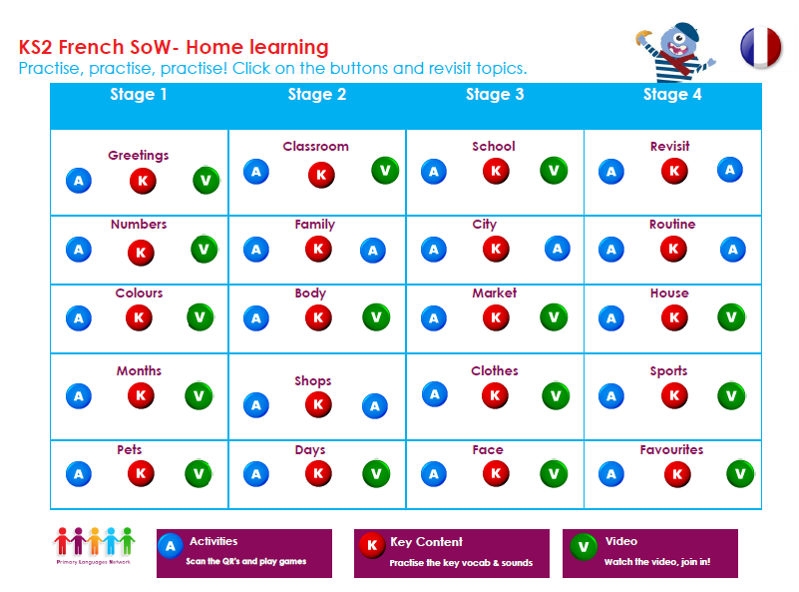

- Here is a way English is linked to other languages. Can you find out which English word is similar to “chicken” and which word is similar to “queen” and which other languages the word is linked to:

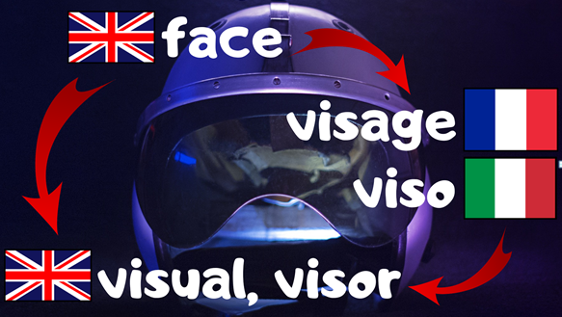
- Let’s go on a virtual tour of Paris – while you travel around you can pause and draw some buildings you see for the next activity.

Try and find: The Eiffel Tower, Sacré Coeur, Arc de Triomphe, the Louvre, Notre Dame,
https://www.youtube.com/watch?time_continue=119&v=nTGUA1rEioA&feature=emb_logo
or
https://earth.google.com/web/@48.8583701,2.2944813,138.6453322a,666.61608691d,35y,0h,45t,0r/data=ChIaEAoIL20vMDJqODEYAiABKAI

- Great British Bunting - You might know that on Friday we are celebrating the 75th VE Day – which is Victory in Europe Day – linked to the Second World War – your task is to create a banner or two and decorate it with the buildings from your Paris tour, flags of European Countries and French and English word and add to any English bunting you might be making!!!

https://www.bbc.co.uk/programmes/articles/4TrqYDyf4PMdLypxzyTwGDg/great-british-bunting

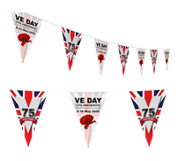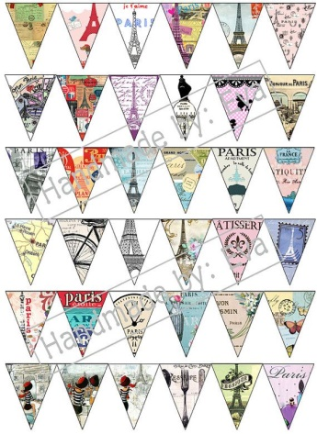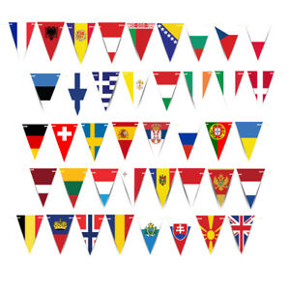

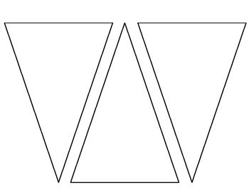

Please send me your work to the email below.

Mrs Oseman – mrsoseman@crumpsall.manchester.sch.uk

