Draw It!

Read each Easter egg description. You will remember some of the words and you can use this dictionary to find the meaning of “fleur” .
https://dictionary.cambridge.org/dictionary/french-english/
Draw what it says on the egg and decorate it. So, on the first one you will draw one rabbit! Careful with the numbers and animals!

- Un lapin.

2. Deux poissons
bleus.

3. Un lapin, deux poissons et un oiseau.

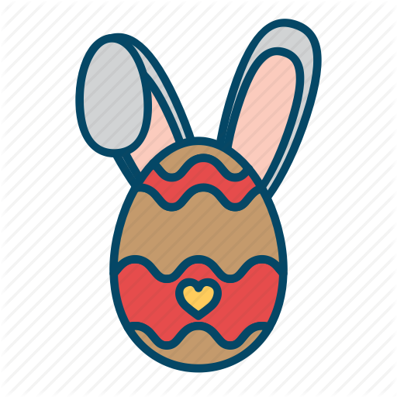

4.Un lapin bleu et un oiseau rouge.

5.Cinq fleurs et un oiseau jaune.

6.Quatre fleurs, deux lapins et un mouton.

