What the Ladybird Heard
title
illustrator

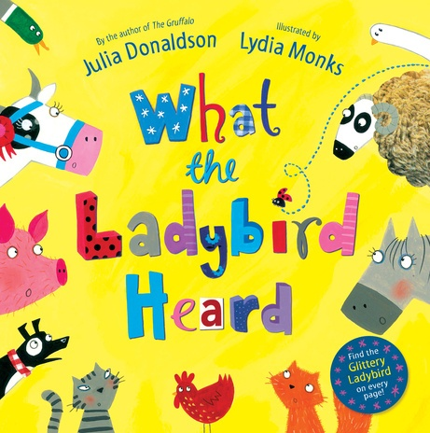

author
front cover

Name __________________________________
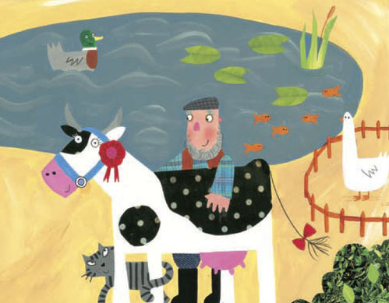
Find the missing words!

Meet the animals who live on the farm.

Once upon a farm lived a fat _ _ _ _ _ _ ,
A duck in a _ _ _ _ and a goose in a pen,
A _ _ _ _ _ _ sheep, a hairy _ _ _,
A handsome _ _ _ _ _ and a _ _ _ _ _ _ dog,
A cat that miaowed and a _ _ _ that purred,
A fine _ _ _ _ _ cow …….
and a ladybird.
red hog
woolly horse cat
dainty hen
pond prize

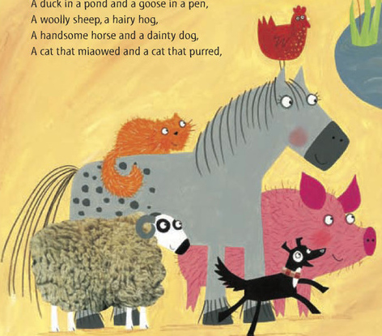

Follow the route
Listen to the instructions that the ladybird heard and follow the route that Hefty Hugh and Lanky Len planned to follow to reach the farmer’s fine prize cow.

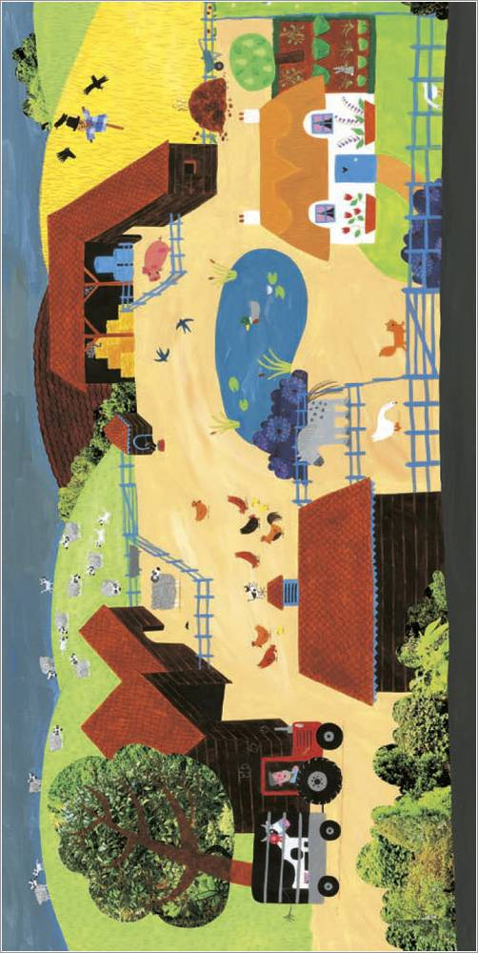

Who makes that sound?
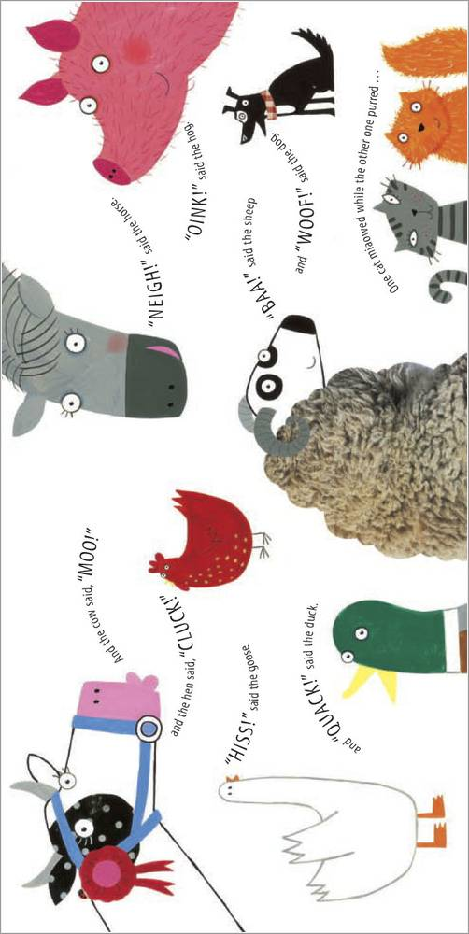
Match the right sound to the right animal.
purred baa oink moo cluck
woof hiss neigh miaowed quack

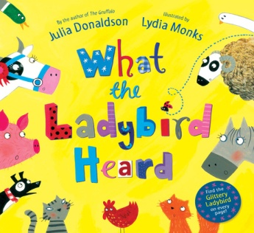
Draw your favourite part of the story

I liked it when _______________________________________
_______________________________________
_______________________________________
_______________________________________
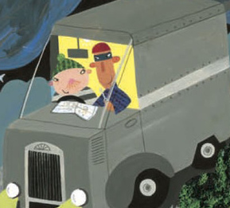
Things beginning with ‘h’
Hefty Hugh is one of the robbers.
Can you sort the pictures into the correct group?

Things beginning with ‘l’
The other robber is Lanky Len.
Can you sort the pictures into the correct group?

Sort the pictures
Cut out and paste the pictures into the correct groups.



