Monday 27th April 2020 – Mrs Halim
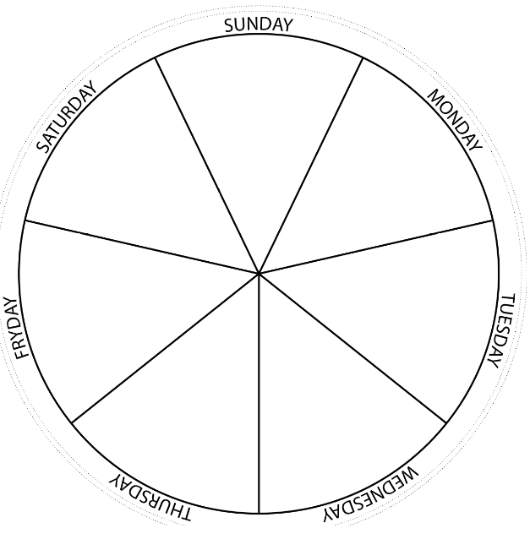
Can you write or draw what you do each day of the week?

