Pet Menus

To write a menu for your pet…
- Choose your pet.
- Find out if your pet is an omnivore, carnivore or herbivore.
- Write a suitable menu for your pet.
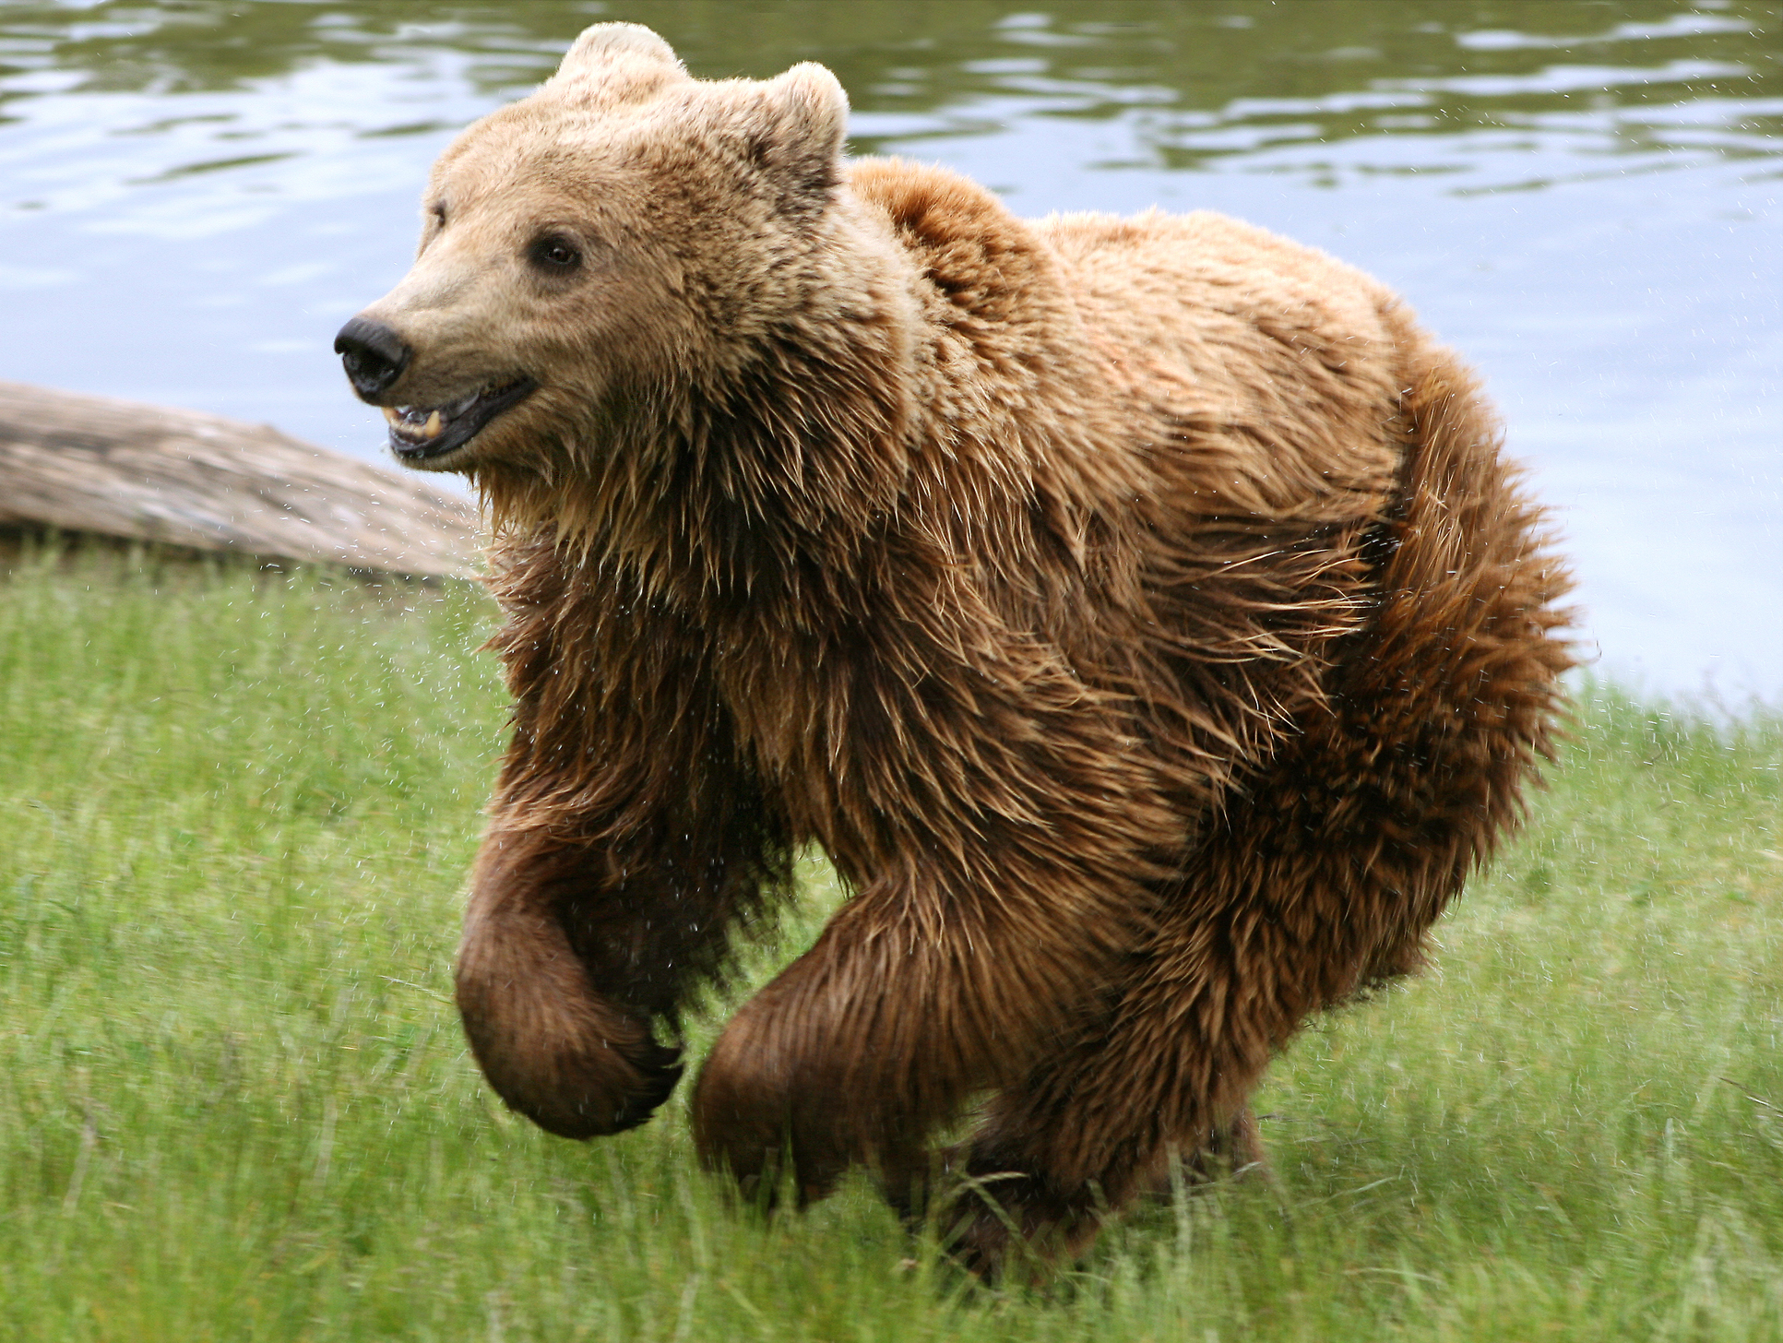
Omnivores eat meat and vegetables. Here are some examples of omnivores:
- Some people
- Bears
- Dogs

Carnivores only eat meat. Here are some examples of carnivores:
- Wolves
- Lions and tigers
- Toads
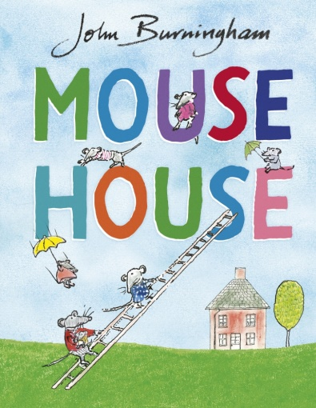

Herbivores only eat vegetables. Here are some examples of herbivores:
- Some people
- Goats
- Geese
