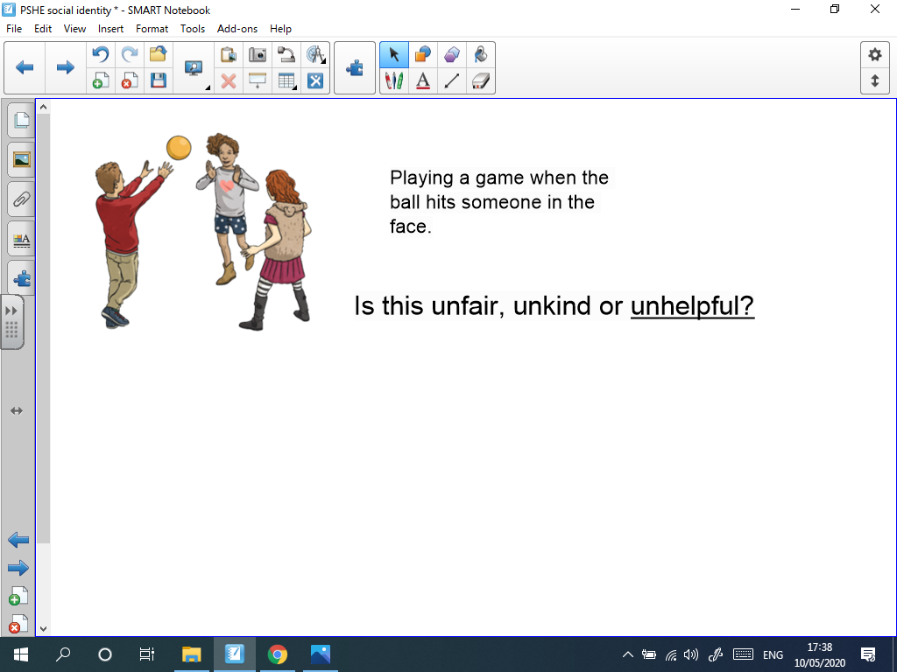
Choose if the scenarios are unfair, unkind or unhelpful. Then write a sentence to explain why you think the scenarios are unfair, unkind or unhelpful.

It is______________________________________________________________________________

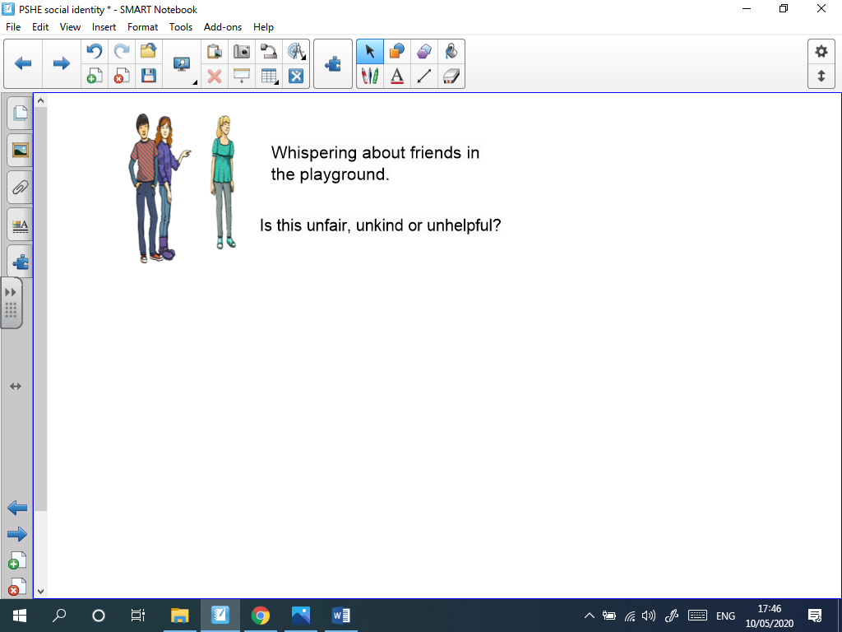
__________________________________________________________________________________

It is

__________________________________________________________________________________

