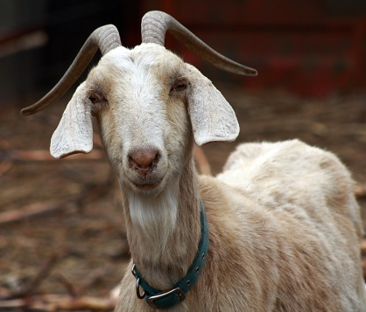
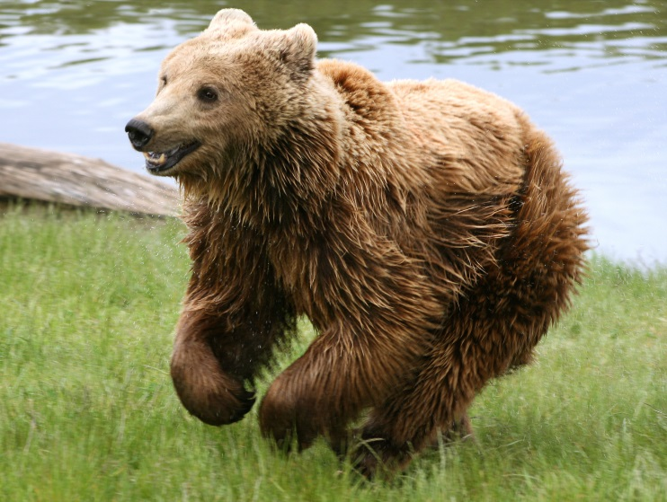
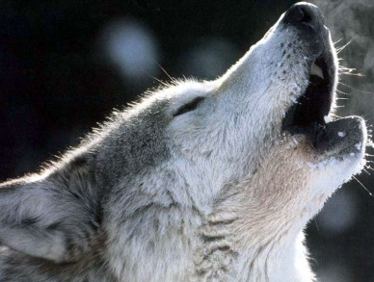
Pet Week
This week we will be looking at pets. Today I want you to pick any animal in the world to be your pet. Can you draw it and write a list of adjectives (describing words) to describe your pet. You can even give it a name! The best pictures will appear on our blog.

