Pet Week
Now you have picked your pet and described it. Just like our story “How to was a woolly mammoth” Can you write ten instructions for washing your animal.
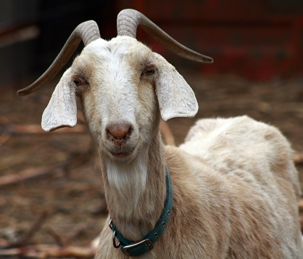
Mine is going to be “How to wash a smelly goat”

Here is the original:
- Fill the tub.
- Put in some bubbles.
- Add the dirty woolly mammoth.
- Then scrub the dirt on your mammoth.
- Wash his big fat belly.
- Shampoo his head, careful not to get it in his EYES!
- To get a woolly mammoth down from a tree, you will need a very large trampoline.
- Let the mammoth share the bath with you.
- Dry your mammoth.
- Throw in the towel and snuggle.

