The lion, The Witch and The Wardrobe- The Snowy Forest
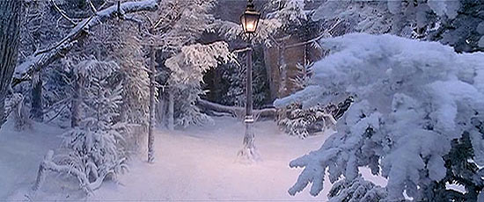
Gliding gently through the cold, refreshing air, the delicate, patterned snowflake lands on my face and in a matter of seconds, its glorious pattern turns into a bead of water, which rolls carefully down my raw, pink cheek. When I gaze up into the cool, snowy air I notice that the trees are covered in blankets of snow and every second a small piece of snow joins the collection.
Wishing that this moment could last forever, I watch a blade of sun catch the snow – it looks like magic caught in the light. Heavenly pieces of snow crunch under my feet, while I walk along the forest path, hoping I will be able to enjoy this scene for a little while longer.

Questions:
- Who or what is narrating?

- Underline and clarify and words you do not know the meaning of.
Some examples that you might need to clarify are:
Gliding
Delicate
Glorious
Raw
Gaze
Heavenly

- Summarise the extract in 20 words or less- focus on how the extract made you feel and why…

