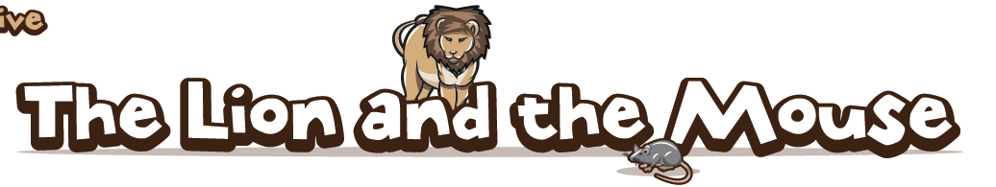
In the scorching heat of the savannah, a small mouse crept quietly up to a lion. The mouse carefully tip-toed around the lion’s long, thick tail and warily made his way round in front of the lion. As the mouse slowly looked upwards, _______________________________________________________ ________________________________________________________________________________________________________________________________________________________________
Suddenly, the mouse was shocked when he heard a rumbling noise coming from the lion’s belly but it wasn’t hunger because the lion was asleep. With this, the mouse stood up on his hind legs, stretched out his tail and lifted his head up high. “Since he’s sleeping, I’ll climb over this beast,” thought the mouse, “He’ll never know I’m here.’ With that, the brave, little mouse quickly _______ ________________________________________________________________________________________________________________________________________________________________________________________________________________________________________________
Ferociously, the lion fired out his enormous claws and aggressively grabbed the mouse by its tail.
"Please," squeaked the mouse, "let me go and I'll come back and help you someday."
The lion laughed loudly, "___________________________________________________________".
The colour drained from the mouse’s face and his tiny heart raced in his rib cage. Why had he been so stupid to try and climb over a sleeping lion? “Please, one day I will be able to help you. I am s..o..r…..r….y!” squeaked the mouse again. With this, the lion felt another rumble of laughter roaring through his body. He laughed so hard that he actually had to hold his belly! As soon as he did, the mouse nervously leapt to the boiling hot floor below and scampered away as quickly as he could.
The very next day, two hunters, who had been hunting in the area for weeks, came to the jungle in search of a prize catch. Unluckily for the lion, they were after him and they had tracked him to his lair, which was slightly hidden between a collection of tall trees. As the sun began to set and the stars twinkled in the clear, night sky, the two hunters _____________________________________ ________________________________________________________________________________________________________________________________________________________________________________________________________________________________________________________________________________________________________________________________
From a short distance away, the mouse heard the lion's pitiful roar and _______________________ ________________________________________________________________________________________________________________________________________________________________________________________________________________________________________________________________________________________________________________________________________________________________________________________________________________

