LO: Can I recognise and discuss some of the symbols in the Easter story?
Look through the power point of the Easter story and list the symbols mentioned. Then think about what the symbols might mean.
Can you fill in the missing words and draw a picture for the third box? (How do Christians believe Jesus died?)
_______________ is a symbol of Jesus’ body. | 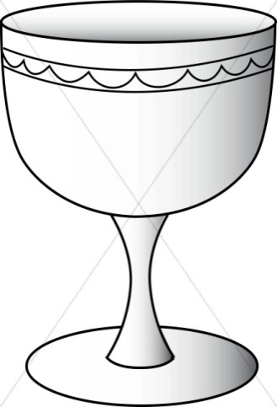  _______________ is a symbol of Jesus’ ________________.
Jesus _______________ on  the ___________________. | Reflection; Why is Jesus special to Christians?  Jesus is special because …..  ________________________  ________________________  _______________________

R A G

