Think about some activities that people do in your environment.
Here are some activities: riding a bicycle, playing football, tennis, cricket, going to the park.
There are lots of other activities but I’ll leave that for you.

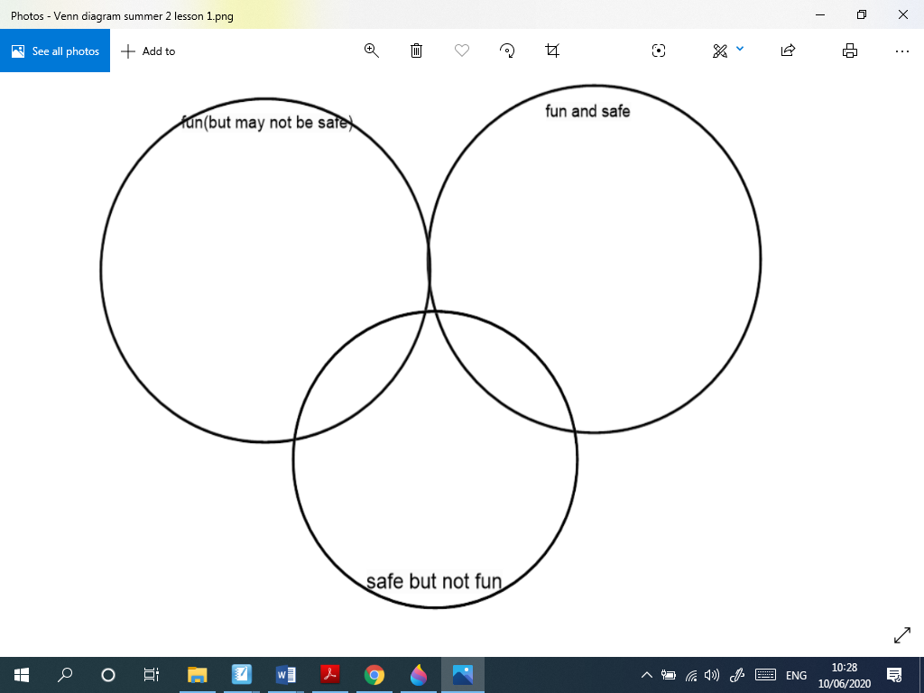
You need to fill in the venn diagram with activities to show if they are fun and safe, fun but may not be safe, safe but not fun. You may draw the activities if you choose .

