Can I say how I show that I’m responsible?
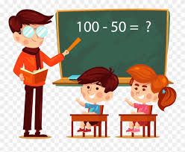

This teacher is responsible because he is teaching the children.

Draw a picture to show how you are responsible in school. You can write a sentence or label your drawing.

Word bank: tidy up, give out fruit, wash my hands, dress myself, give out pencils, give out scissors.

