

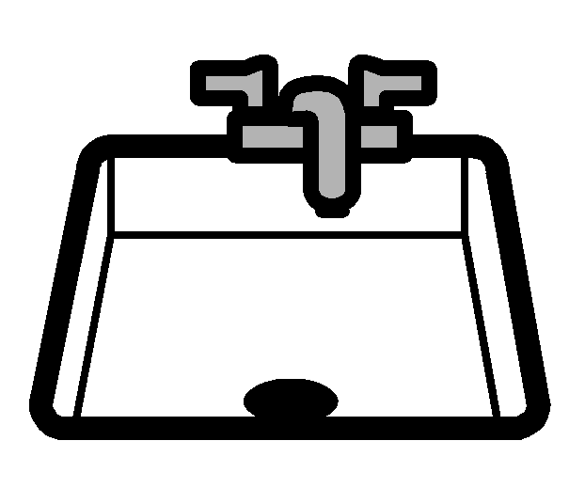



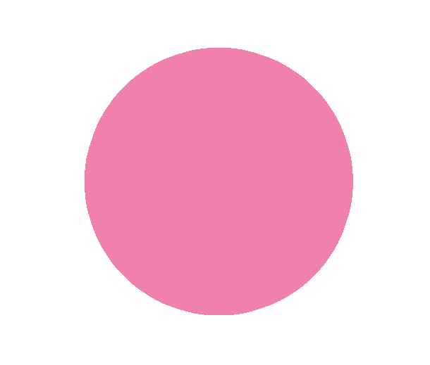











and

and

Sung to ‘Old MacDonald has a Farm’

What’s the sound that ends these words

**nk** is the sound that ends these words

With a **nk** here and a **nk** there,

Here a **nk** there a **nk** everywhere a

**nk** **nk**

**nk** is the sound that ends these words

and