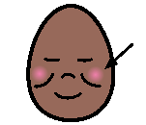

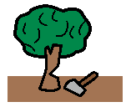

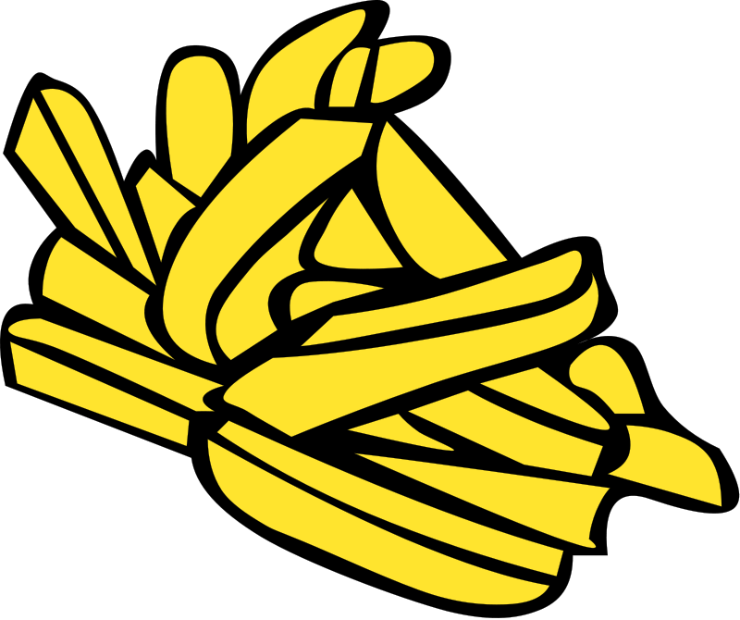

Sung to ‘Old MacDonald has a Farm’

What’s the sound that starts these words

**ch** is the sound that starts these words

With a **ch** here and a **ch** there,

Here a **ch** there a **ch** everywhere a

**ch** **ch**

**ch** is the sound that starts these words













and

and

and