Run- Snow Patrol
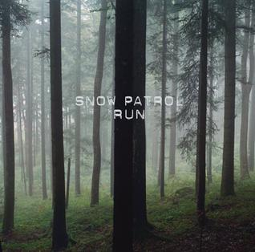
- How does the singer capture the listeners interest in the first line?
- What do you think the word barely means in the line ‘and I can barely look at you’?
- Where does the singer promise he will be, even when his voice can’t be heard?
- What do you think the phrase ‘long goodbyes’ means?
- Why do you think the singer nearly cries when saying goodbye?
- Who do you think the singer is talking to in this song? Why?

