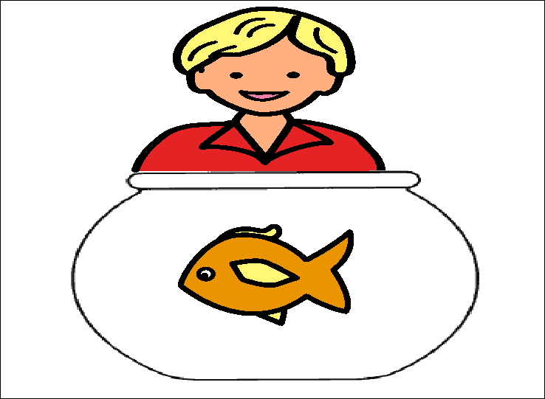

Ed’s fish is fun. It can swim fast in the tank.



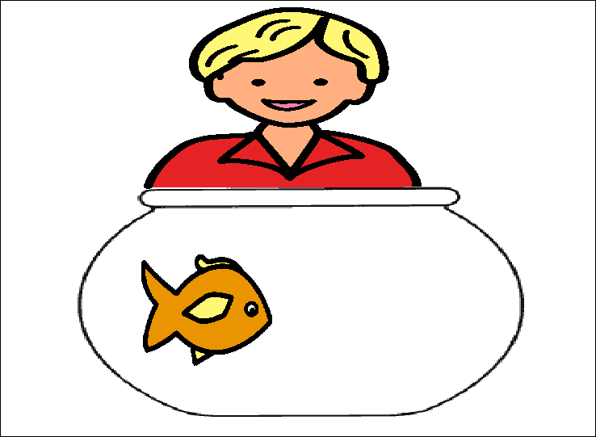

Ed’s mum got a red fish and put it in the tank.

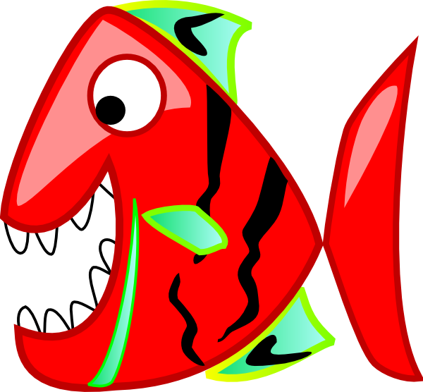





Ed’s fish was sad.The red fish was bad and mad.

1`h