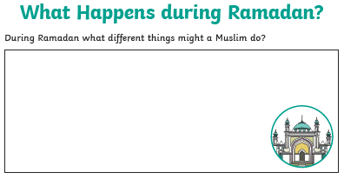
Tuesday 21st April 2020 – Mrs Halim
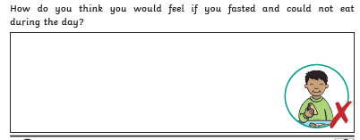
What does fasting mean for Muslims?
Reflection: What special deeds can you do during Ramadan?

_________________________________________________________________________

