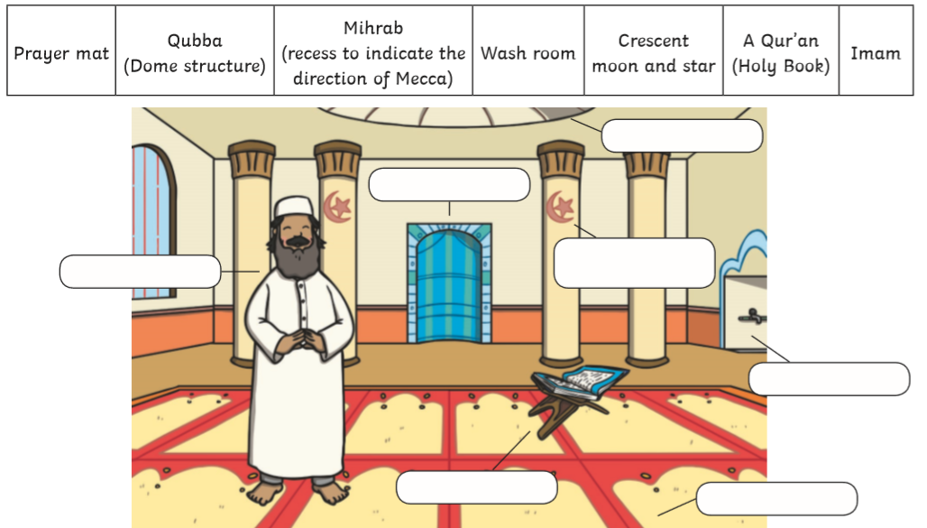

Reflection: How do you think Muslims feel when they pray in the mosque?
____________________________________________________________________________________________
____________________________________________________________________________________________

