How to get your work
Open Google Classroom. Click the ‘Classwork’ tab
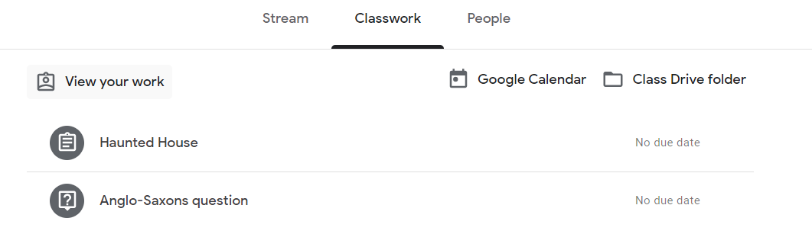‘View Your Work’. This shows you the assignments that you have to do.

How to hand in your work
You can open documents in Google docs and Share when completed.

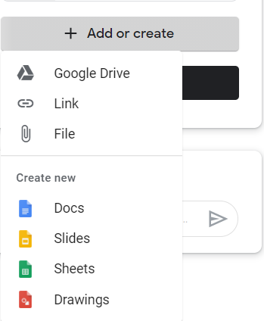

You can upload a saved
file.- this can be s saved photo
or video.

You can create a new doc &
upload that as your work.

Handing in work
When your child has finished their work, tap ‘Hand In’
Then Click ‘Hand in’ again to confirm.
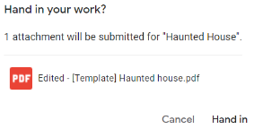
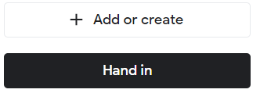

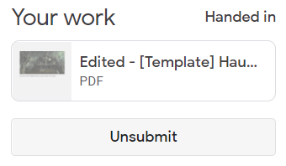
If you have made a mistake, you can click ‘Unsubmit’.

The teachers can see what your children are completing and can add comments to their work when it is handed in.
We ask parents to support their children with adhering to the online code of conducts for Google Classroom.
This will be sent home as a separate document.

Crumpsall Lane
Primary School

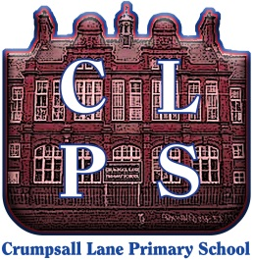

Google Classroom

An information leaflet to support parents to use our online learning platform.

Follow these steps so that your child can continue to complete learning activities at home if they are unable to come into school.

SMARTPHONES & TABLETS

Android devices
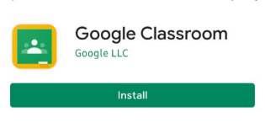
Open the Play Store App
Search for Google Classroom
Tap ‘Google Classroom’
Tap ‘Install’

iOs devices (iphones, iPads etc)
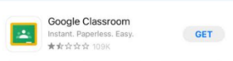
Open the App Store App
Search for Google Classroom
Tap ‘Google Classroom’
Tap ‘Get’

Getting Started
Open the app. Click Get Started.
Log in with your child’s new log in details.
This has come home with your child on blue paper.
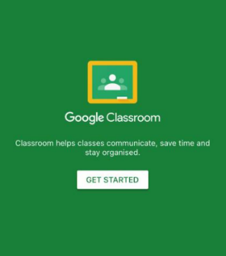
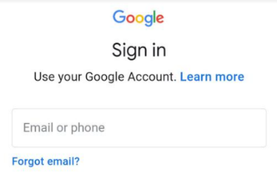

You should then have access to the Google Classroom for your child’s class.
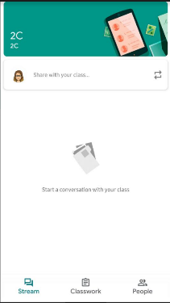

How to get your work
Open Google Classroom
and tap here (Classwork)

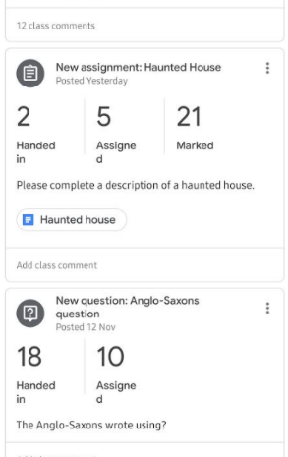
The list of assignments
for your child are there.
Click to download.

Depending on the task, your
child can work directly onto
the downloaded assignment
or on paper.

How to hand in your work
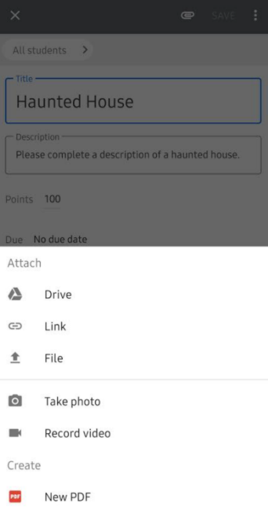
Click the paperclip.

You can upload a saved file.

You can take a photo of any
completed work.

You can record a video of work.

Handing in work
When your child has finished their work, tap ‘Hand In’
Then Click ‘Hand in’ again to confirm.
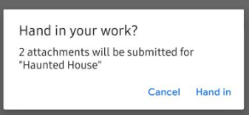
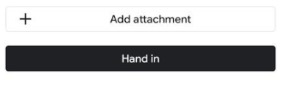

If you make a mistake, you can click ‘Unsubmit’

-------------------------------------------------------------------

LAPTOPS & PCs

Go to www.classroom.google.com
Log in with your child’s new log in details.
This has come home with your child on blue paper.
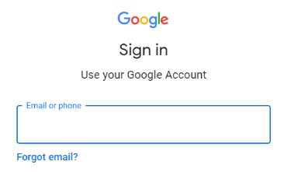

You should then have access to the Google Classroom for your child’s class.

