This year we have looked at “Greater Than” and “Less Than “

Can you copy the pictures on the following sheets and decide which sign you need to use!.

Tomorrow we will be doing this with numbers!

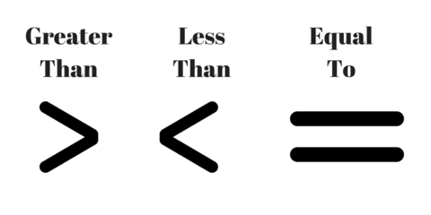

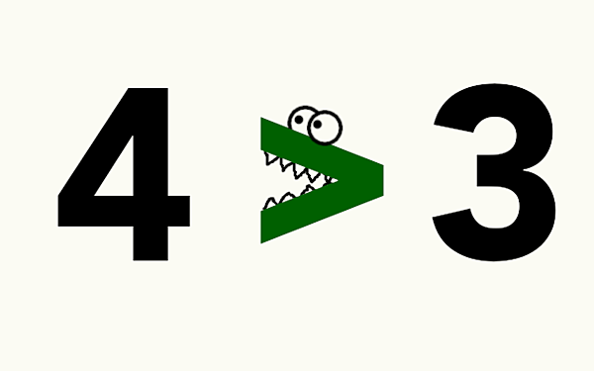

LT: find greater than and less than.

Can you make the greedy crocodile eat the bigger amount of food?

|  |  |  |
| --- | --- | --- |
|  |  |  |
|  |  |  |
|  |  |  |
|  |  |  |
|  |  |  |
|  |  |  |
|  |  |  |
|  |  |  |
|  |  |  |
|  |  |  |
|  |  |  |

LT: find greater than and less than.

Can you make the greedy crocodile eat the bigger amount of food?

|  |  |  |
| --- | --- | --- |
|  |  |  |
|  |  |  |
|  |  |  |
|  |  |  |
|  |  |  |
|  |  |  |
|  |  |  |
|  |  |  |
|  |  |  |
|  |  |  |
|  |  |  |

LT: find greater than and less than.

Can you make the greedy crocodile eat the bigger amount of food?

|  |  |  |
| --- | --- | --- |
|  |  |  |
|  |  |  |
|  |  |  |
|  |  |  |
|  |  |  |
|  |  |  |
|  |  |  |
|  |  |  |
|  |  |  |
|  |  |  |
|  |  |  |

LT: find greater than and less than.

Can you make the greedy crocodile eat the bigger amount of food?

|  |  |  |
| --- | --- | --- |
|  |  |  |
|  |  |  |
|  |  |  |
|  |  |  |
|  |  |  |
|  |  |  |
|  |  |  |
|  |  |  |
|  |  |  |
|  |  |  |
|  |  |  |

|  |  |  |  |  |
| --- | --- | --- | --- | --- |
|  |  |  |  |  |
|  |  |  |  |
|  |  |  |  |
|  |  |  |  |
|  |  |  |  |
|  |  |  |  |
|  |  |  |  |
|  |  |  |  |
|  |  |  |  |
|  |  |  |  |
|  |  |  |  |  |
|  |  |  |  |  |
|  |  |  |  |  |
|  |  |  |  |  |