Mrs Halim
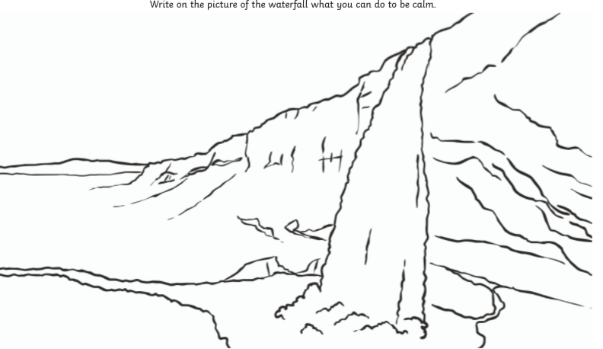
LO: Can I describe what makes me calm?
Reflection: Why is it important to be calm?
_____________________________________________________________________________________________ R A G

