Date: _________________________________________

Can I describe jungle animals and use a bilingual dictionary?
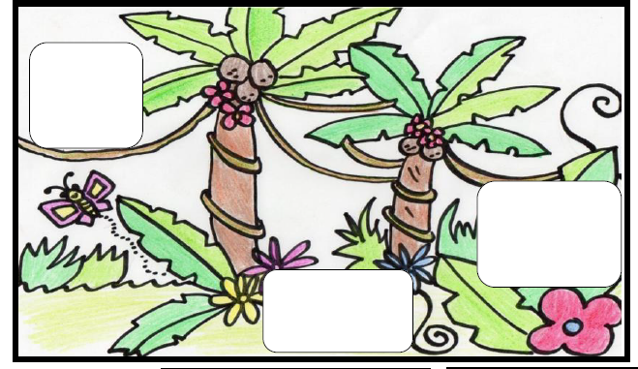

- Qu’est-ce que tu peux voir? – What can you see?
- Je vois - I see
- une giraffe, un serpent, un singe, un tigre, un perroquet, un éléphant
- long(ue, vert(e), grand(e), orange, petit(e) multicolore, vite , marron, terrible, gris(e)

