Can I describe a jungle?
Look at the images of the jungle, have a look through different pictures and see what you can describe. Write adjectives around the images that show what you can see.
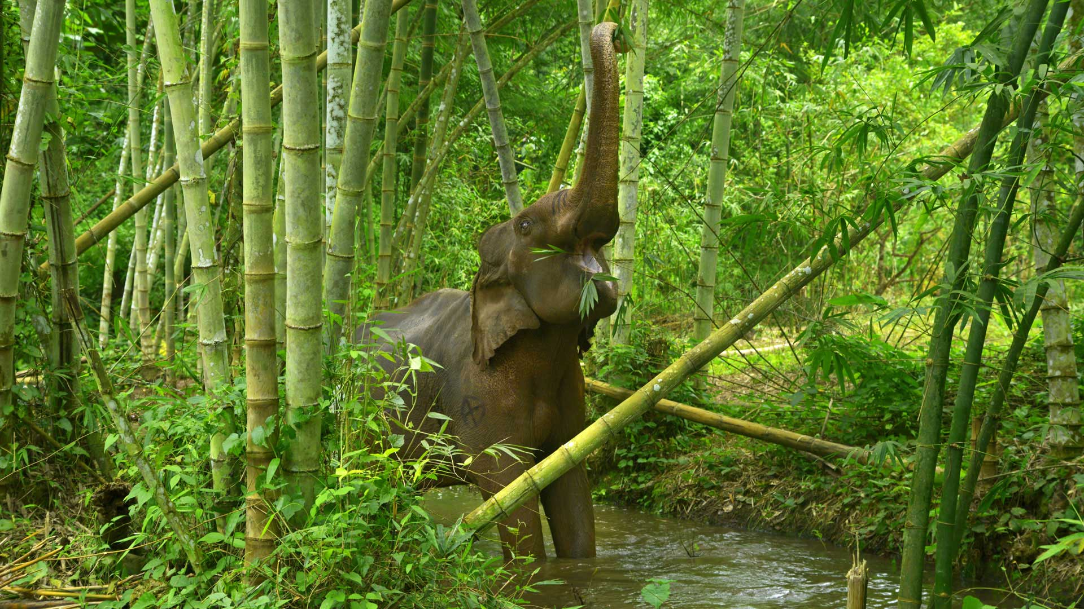
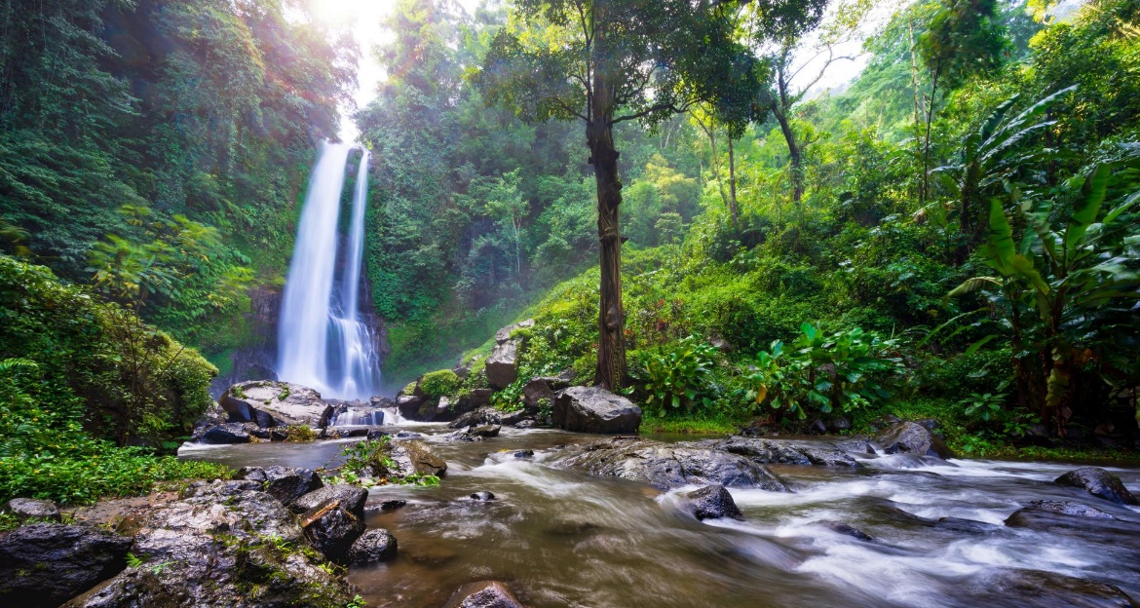

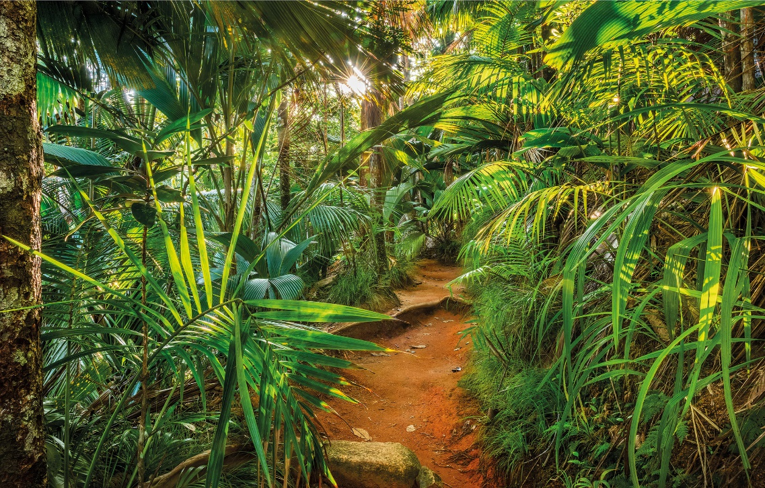
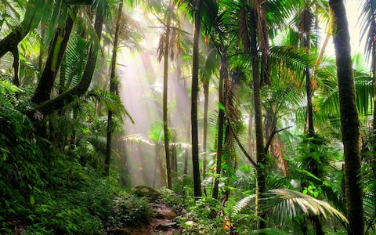

Imagine we have gone through the wardrobe together and we are in a new jungle. If I passed you my binoculars, an instrument that makes faraway objects look closer, what would you see through them? What would the jungle be like? What weird and wonderful things would be there?
Creative Challenge: In the binoculars below, draw what you would see through them.
