Mrs Halim
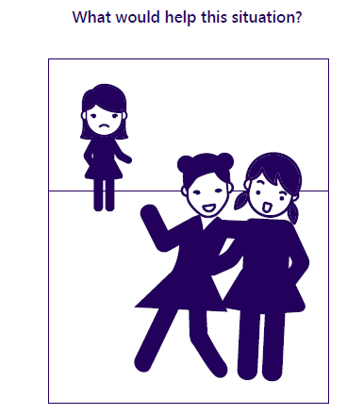
Can I sort out friendship problems?

Reflection: What could you do to help in this situation?
__________________________________________________________
__________________________________________________________
__________________________________________________________
R A G

