Hello Year 3
RE – Islam – Hajj
Remember how we have been talking about special journeys and that we started looking at the Hajj pilgrimage.
We discussed what was in the suitcase and why.
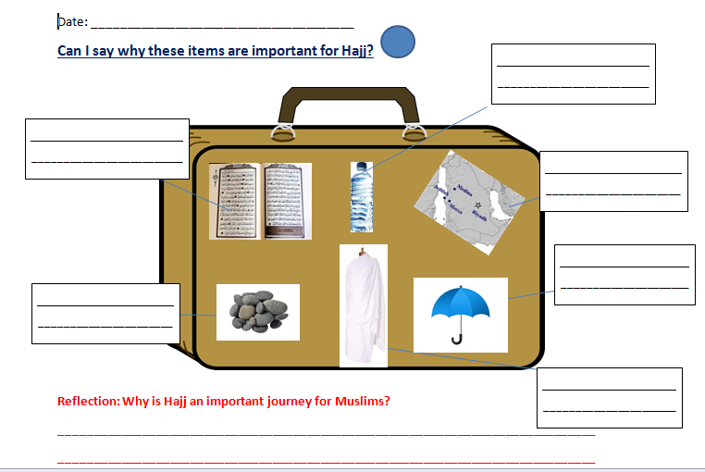
This week we are finding out and remembering the order of events during the Hajj. You can go through the PowerPoint then see if you can number the pictures in the correct order.

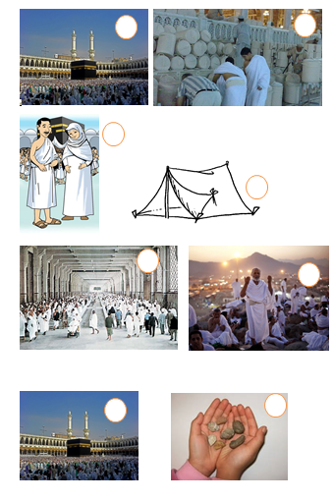
Mrs Oseman & Mrs Halim

