Extracts of spells and potions from other stories…

EXTRACT ONE
From ‘The Cook-up’ (p.34)
‘Fiery broth and witch’s brew
Foamy froth and riches blue
Fume and spume and spoondrift spray
Fizzle swizzle shout hooray
Watch it sloshing, swashing, sploshing
Hear it hissing, squishing, spissing
Grandma better start to pray.’

EXTRACT TWO
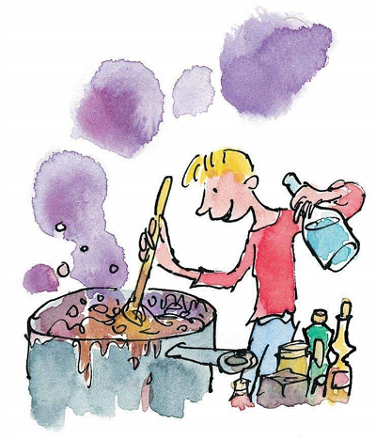
Double, double toil and trouble from Macbeth by William Shakespeare
Double, double toil and trouble;
Fire burn and caldron bubble.
Fillet of a fenny snake,
In the caldron boil and bake;
Eye of newt and toe of frog,
Wool of bat and tongue of dog,
Adder’s fork and blind-worm’s sting,
Lizard’s leg and howlet’s wing,
For a charm of powerful trouble,
Like a hell-broth boil and bubble.
Double, double toil and trouble;
Fire burn and caldron bubble.
Cool it with a baboon’s blood,
Then the charm is firm and good

