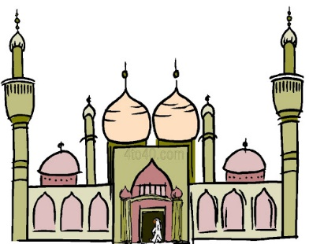
Mrs Halim (Level 1 – AT1)
LO: What activities or events can take place in a mosque ?
Can you draw and write about three activities or events can take place in a mosque?

____________________________ | ____________________________ | ____________________________

Reflection: Why is the mosque important to Muslims?
_____________________________________________________________________________________________________
R A G

