The Mystery of the Crumpsall Lane Wall
Yesterday we found out that our suspect is Female! I have updated the suspect list.
Teacher | Gender | Year group taught | Height
Mrs Kendall | Female | Reception | 25 CM
Ms Syme | Female | Reception | 15 CM
Mrs Owens | Female | Year 1 | 19 CM
Mrs Cassidy | Female | Year 1 | 18 CM
Ms Ahmad | Female | Year 1 | 16 CM
Miss Edwards | Female | Year 2 | 19 CM
Mrs Pearce | Female | Year 2 | 23 CM
Miss Kayani | Female | Year 3 | 22 CM
Miss Humphreys | Female | Year 3 | 18 CM
Miss Bell | Female | Year 4 | 21CM
Miss Lashmar | Female | Year 4 | 17 CM
Miss Cloherty | Female | Year 6 | 24 CM
Mrs Williams | Female | Year 6 | 19 CM
Mrs Fairclough | Female | Head of School | 27CM

Hello Detectives!
I have looked at the cameras at school and found this picture.
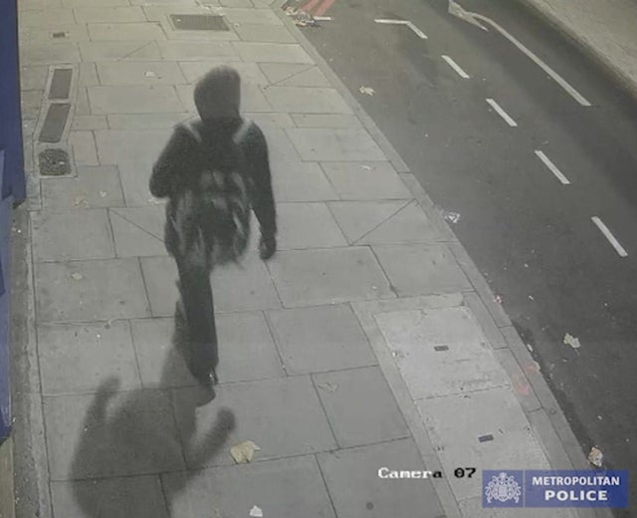
This is the bad teacher who drew on our wall!
Using my ruler I found that this person is less than 20 CM.
Can you cross everyone off our list who is less than 20 CM.
Use this ruler to help you work out which numbers are less than 20CM.

