Crumpsall Lane Primary School
Remote Learning Policy
October 2020

Date of review | Changes to document

Jan 2021

Contents:
1. Aims 3
2. Roles and responsibilities 3
3. Who to contact 6
4. Data protection 6
5. Safeguarding 7
6. Monitoring arrangements 7
7. Links with other policies 7

1. Aims
This remote learning policy is aims to:
- Ensure a consistent approach to remote learning for pupils who aren’t in school
- Set out expectations for all members of the school community with regards to remote learning
- Provide appropriate guidelines for data protection

2. Roles and responsibilities

2.1 Teachers

Teachers are responsible for:
Remote teaching when working from home and they are not unwell:
- Liaise with whoever is supporting in their class in their absence, ensuring a clear timetable for when they teach remotely throughout the day has been shared.
- Ensure that all resources have been shared with the cover teacher or class TA to be printed and copied ahead of any lessons.
- Cover teacher to mark work if appropriate and initial.
- If TAs are supporting the class, they must update the class teacher on the outcomes for the children in the class to enable the teacher to plan effectively for the next lesson.
- Extended pieces of writing to be marked by the teacher on their return to school.
- Teacher to be available between the hours for 8:30am and 3:30pm Monday Tuesday and Friday. 8:30am-4:30pm on a Wednesday and Thursday.
- All members of staff to attend planned staff meetings.
- Teachers to use time when they are not teaching to get ahead with PPA and leadership tasks. If they return later in the week, they will not then be given additional PPA or leadership time.
- To follow the code of conduct for online teaching (Appendix 1)

Setting work on our online platform when the whole class is isolating:
- Creating a weekly timetable of work for their year group in liaison with year group partners. This must include subjects from across the curriculum.
- Set differentiated Phonics or SPaG, English and Maths work each day on Google classroom. Ensuring that there is consistency across the year group.
- Working as a year group team to ensure the above work is planned and ready.
- One other piece of work per day; topic, science, PSHE or PE for example.
- Pupils can send any completed work to teachers via Google classroom.
- Teachers to share feedback on any handed in work.
- Teachers should respond to any emails from parents/children within 48 hrs.
- Teachers are to add one piece of good work for Good Work Assembly for SLT.

Keeping in touch with pupils and parents
- Emails received in the year group email from parents and pupils are to be checked between 9am and 3pm, Mon- Fri. Emails must be replied to within 48hrs. Only send replies between these times. Anyone can respond to year group enquiries it does not have to be the actual class teacher.
- Any issues that are received are to be dealt with professionally by the class teacher and the Head of School should be BCC’d in the communication. If necessary teachers to contact their Phase Leader or member of SLT for advice.
- Teachers are to attempt to make contact will all pupils in their class every 2 weeks via telephone call when in school or from a withheld number. Contact details can be accessed from Cpoms/SIMS. Record all contacts with parents on CPOMs and add any relevant actions. Example CPOMS comment ‘Telephoned Mum offered support during home learning and I spoke with child who is getting on well. No concerns.’ Alert family support worker if there are any concerns.
- Contact should be polite and encouraging. Teachers must not give out any personal details. Any concerns should be forwarded to a member of SLT who may choose to contact the parents directly.
Attending virtual meetings with staff, pupils or parents
- Follow the online code of conduct provided by the National Online Safety College
- Dress professionally
- Work in a suitable location, avoiding areas with background noise and with a suitable background.

2.2 Teaching Assistants

Teachers are responsible for:
Remote teaching when working from home and they are not unwell:
- Liaise with their classteacher to see what support they can offer remotely, if any.
- To be available between the hours for 8:30am and 3:30pm Monday Tuesday and Friday. 8:30am-4:30pm on a Wednesday and Thursday.
- Check work emails
- To attend planned staff meetings.
- To use time when they are not teaching to get ahead with Planning and intervention preparation tasks. To complete online training where necessary. If they return later in the week, they will not then be given planning time.
- To follow the code of conduct for online teaching

When the whole class is isolating:
- Supporting pupils with remote learning, as directed by the class teacher.
- Teaching assistants can assess the Google classroom to join meetings with pupils and support the class teacher with setting work, where required.
Attending virtual meetings with staff, pupils or parents
- Follow the online code of conduct provided by the National Online Safety College
- Dress professionally
- Work in a suitable location, avoiding areas with background noise and with a suitable background.

2.3 Subject Leaders
Alongside their teaching responsibilities, as outlined above, subject leads are responsible for:
- Supporting the work set by teachers in their subject.
- Completing any monitoring which can be done out of school (book looks)

2.4 Senior Leaders
Alongside any teaching responsibilities, senior leaders are responsible for:
- Co-ordinating the remote learning approach across the school. Phase Leaders will monitor the effectiveness of remote learning by reviewing work set by teachers weekly and feeding back to the Head of School
- Monitoring the security of remote learning systems, including data protection and safeguarding considerations

2.5 Designated safeguarding lead

The DSL is responsible for:
- Maintaining contact, collating, passing on information and responding to any concerns. See the COVID-19 amendments to the Child Protection Policy.

2.6 IT staff

IT staff are responsible for:
- Creating emails for pupils
- Supporting with providing pupils with technology to enable them to access remote learning effectively
- Fixing issues with systems used to set and collect work. Reviewing the security of systems and flagging any data protection breaches to the data protection officer

2.7 Pupils and parents

Staff can expect pupils to:
- Follow the Blended Learning Home Agreement.
- Keep log in details safe.
- Be contactable during the hours of the school day 9am – 3pm – although they may not always be in front of a device the entire time
- Seek help if they need it, from teachers or teaching assistants
- Alert teachers if they’re not able to complete work
- Be safe online and follow the Code Of Conduct. (Appendix 2)

Staff can expect parents to:
- Follow the Blended Learning Home Agreement. (Appendix 4)
- Communicate appropriately, whilst remote sessions are being delivered. For example, using child friendly language and refraining from using swear words.
- Know log in details for each child and keep these accessible.
- Seek help from the school if they need it
- Support their child/children to complete the work that has been set by the class teachers.
- Be available throughout the school day to be contacted by the class teacher
- Be vigilant when their children are online and follow the code of conduct (Appendix 3)

2.8 Governing board

The governing board is responsible for:
- Monitoring the school’s approach to providing remote learning to ensure education remains as high quality as possible
- Ensuring that staff are certain that systems are appropriately secure, for both data protection and safeguarding reasons

3. Who to Contact and when
If staff have any questions or concerns about remote learning, they should contact the appropriate member of staff for support:
- Issues in setting work – talk to the Head of School, Phase leader or IT support
- Issues with behaviour – talk to the phase leader or any other member of the SLT
- Issues with IT – contact the IT support via email
- Issues with their own workload or wellbeing – talk to their Phase Leader
- Concerns about data protection – Email the Data Protection Officer
- Concerns about safeguarding – Email any DSL
- No contact from a child – Talk to Head of School, DSL, Admin team

4. Data Protection

4.1 Accessing personal data
When accessing personal data for remote learning purposes, all staff members will:
- Have access to CPOMS to record any parent contact or concerns about children, this is accessed via a secure password. Ensure you log out after use. Do not allow access to the site to any third party.
- Access parent contact details from admin staff via SIMs. Any shared contact details will be password protected documents and be deleted after use.
- Not share their personal access permissions with other staff members. SLT have the ability to locate personal details of families when required through securely accessing SIMs/Cpoms.
- Use school laptops and iPads as the preferred devices when accessing any personal information.
- Log out when completing work.
4.2 Processing personal data
Staff members may need to collect and/or share personal data such as email address or phone numbers as part of the remote learning system. As long as this processing is necessary for the school’s official functions, individuals won’t need to give permission for this to happen.
However, staff are reminded to collect and/or share as little personal data as possible online.
Any documents or information shared should be in a password protected document and deleted after use.

4.3 Keeping devices secure
All staff members will take appropriate steps to ensure their devices remain secure. This includes, but is not limited to:
- Keeping the device password-protected – strong passwords are at least 8 characters, with a combination of upper and lower-case letters, numbers and special characters (e.g. asterisk or currency symbol)
- Ensuring the hard drive is encrypted – this means if the device is lost or stolen, no one can access the files stored on the hard drive by attaching it to a new device
- Making sure the device locks if left inactive for a short period of time
- Not sharing the device among family or friends
- Installing antivirus and anti-spyware software
- Keeping operating systems up to date – always install the latest updates

5. Safeguarding
Please see the following for updates concerning safeguarding in relation to home learning.
COVID-19 amendments to the Child Protection Policy this also details reference to remote learning curriculum and risks online.
This policy is available on our website.

6. Monitoring Arrangements
This policy will be reviewed as and when updates to home learning are provided by the government by Head of School
At every review, it will be approved by the Executive Headteacher.

7. Links with other policies
This policy is linked to our:
Behaviour policy
Child protection policy and coronavirus addendum to our child protection policy
Data protection policy
Online safety policy

Appendix 1
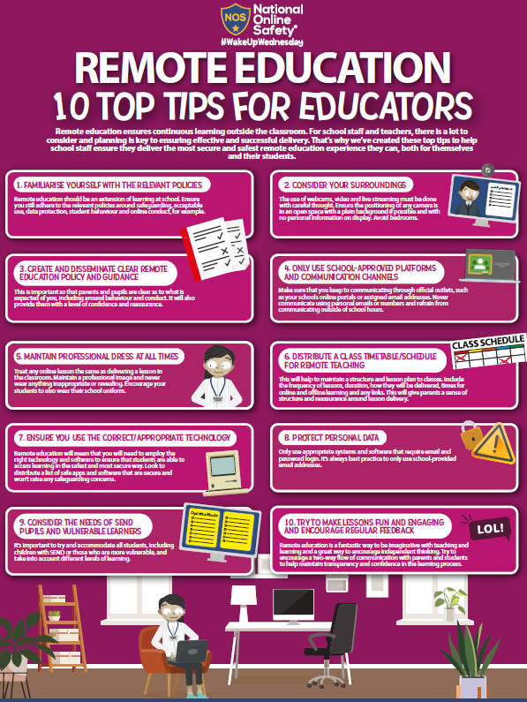

Appendix 2
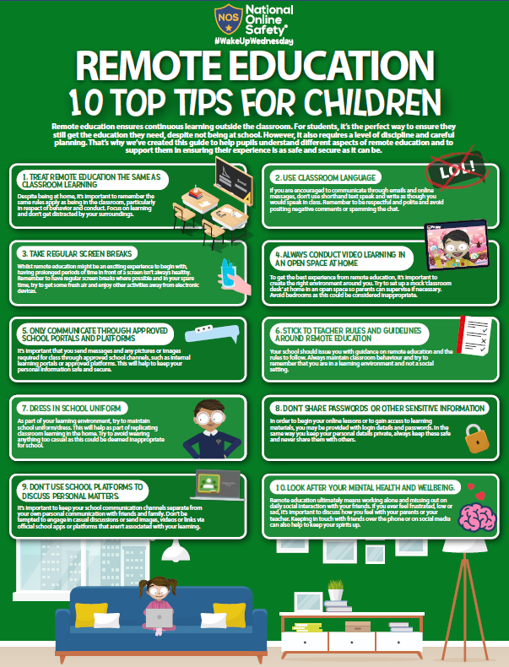

Appendix 3
