Brilliant Bugatti for only £900,000!
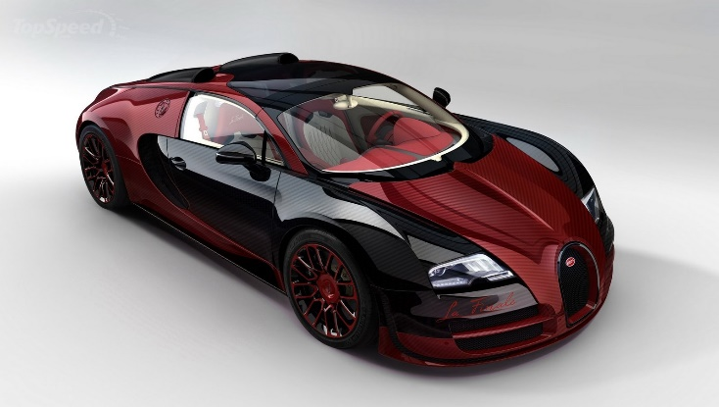

Are you getting tired of your old, boring car? Do you ever dream of driving a brand new, powerful sports car? Then look no further! We are convinced that we have the answer to your dreams. Currently, we have an incredible Bugatti (one of the fastest cars in the world) for sale at the bargain price of £900,000. Although a few of you may think this price is high, it is very reasonable compared to other sports cars such as a Ferrari. The Bugatti, which has a top speed of 267 mph, has an 8 litre engine and four turbochargers. You must buy this stunning feat of engineering immediately!
Other key features of the Bugatti include:
- an engine that delivers 1500 HP
- LED headlights
- leather seats
Cohesive device key
Time conjunctions in red
Pronouns in blue
Conjunctions in green
Determiners in purple

