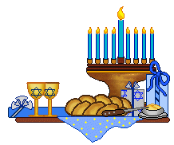
Mrs Halim (Level 1 – AT1)
LO: Can I retell the story of Chanukah?
Can you draw and write what happened in the Chanukah story?

____________________________ | ____________________________ | ____________________________

Reflection: Can you list some of the symbols for Chanukah?
_____________________________________________________________________________________________________
R A G

