Mrs Halim – (Level 1 – AT2)
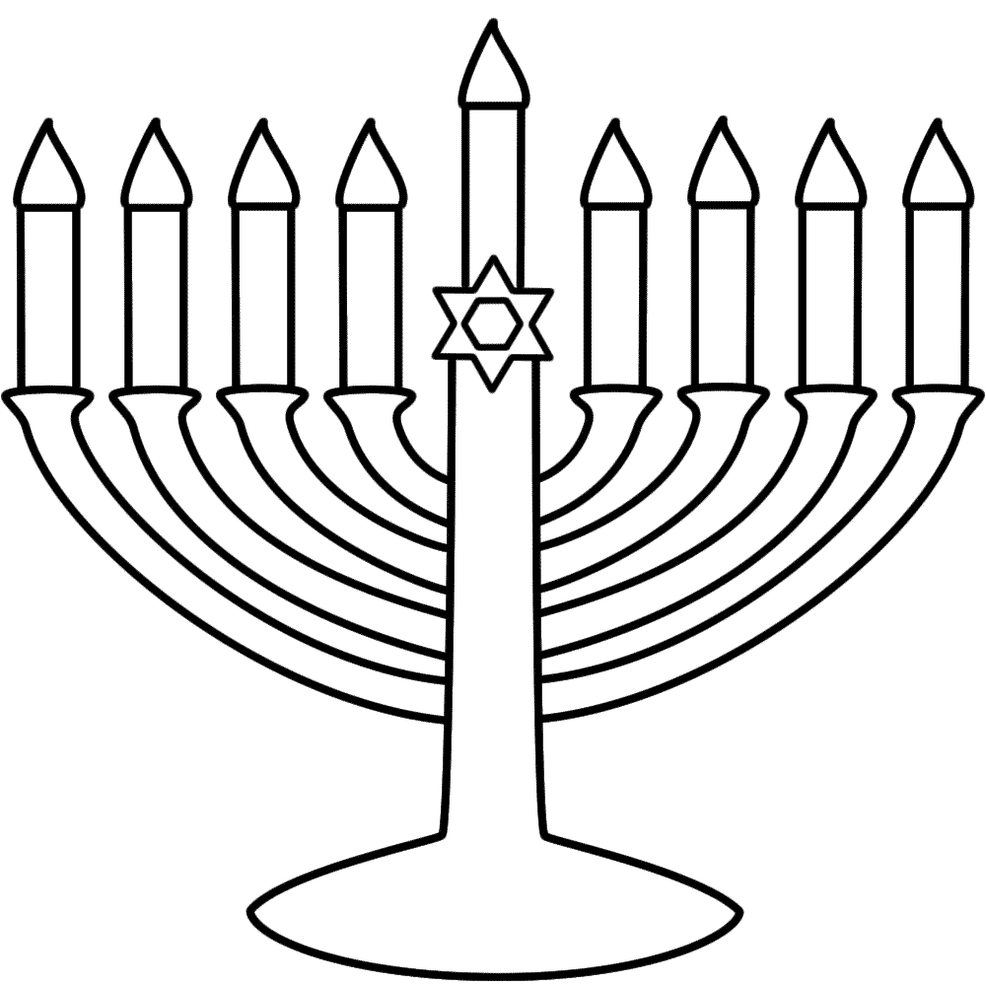
LO: Why are the Chanukah candles important to Jewish people?

The Chanukah candles are important because:
___________________________________________________________

How else do Jewish people celebrate Chanukah?
_______________________________________________

Reflection: How would a Jewish child feel taking part in Chanukah?
_____________________________________________________________
R A G

