Can I discuss different outcomes to an unsafe scenario?

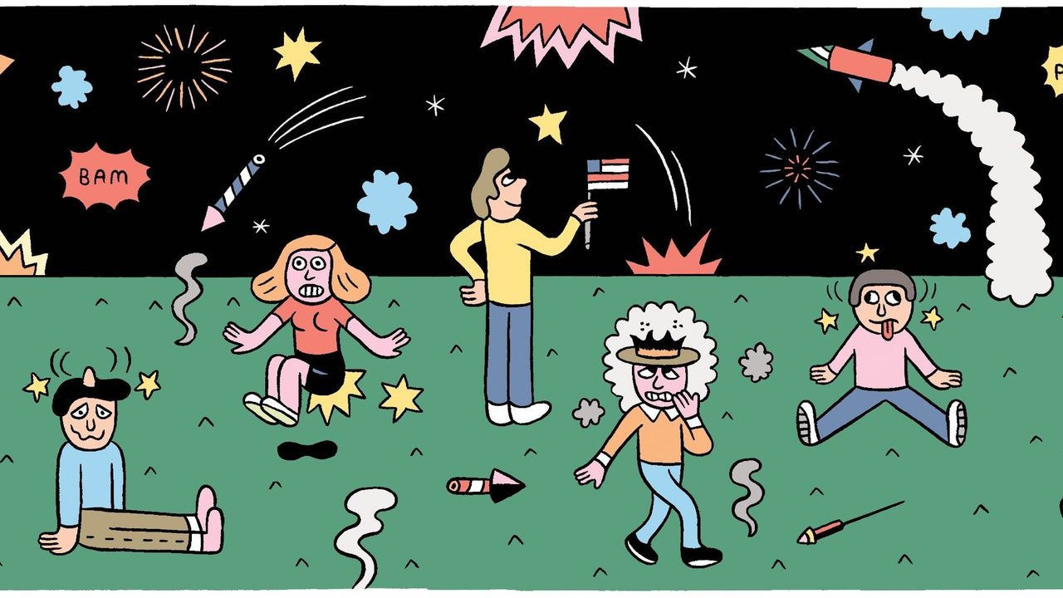

Your friend’s 13 year old sister has some fireworks and she wants you and your friend to go to the park with her while she lights the fire works.
You need to explain what might happen if you
- Agree to go with her.______________________________________________________________________________________________________________________________________________________________________________________________________________________________________________________________________________________________________________________________________________________________
B)
Refuse to go with her:______________________________________________________________________________________________________________________________________________________________________________________________________________________________________________________________________________________________________________________________________________________________________________________________________________________________________________

