Mrs Halim
LO: Can I recognise strong emotions?
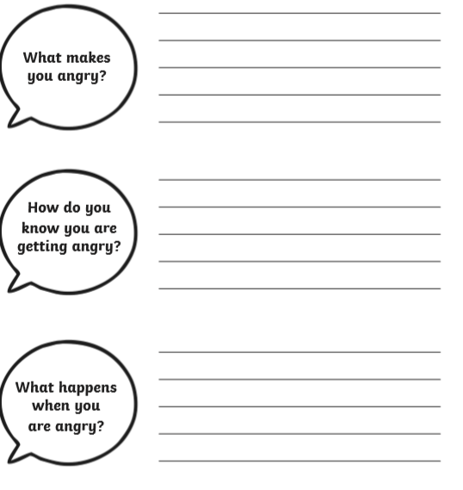
We all get get angry at times. It is fine to be angry but we must learn to recognise and control our emotions approppriately according to the particular situation.
Reflection: What can you do to calm yourself down?
________________________________________________________________________________________________________________________________
R A G

