Can I discuss stereotyping?

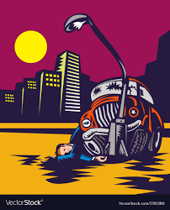
A man backs his car into a lamppost.
Would it be true to say that all men are terrible drivers?
How does this make you feel?
Discuss this. _________________________________________________________________________________________________________________________________________________________________________________________________________________________________________________________________________________________________________________________________________________
A suicide bomber who ‘claims’ to be Muslim, kills innocent people.
Does this mean all Muslims are terrorists?
How does this make you feel?
________________________________________________________________________________________________________________________________________________________________________________________________________________________________________________________________________________________________________________________________________________________________________________________________________________________________________________________________________________________________________________________________________________________________________________

