**Can you write a sentence for each picture of the Easter Story? Draw a picture of how Christians believe Jesus died.**

**Can I recall parts of the Easter story?**

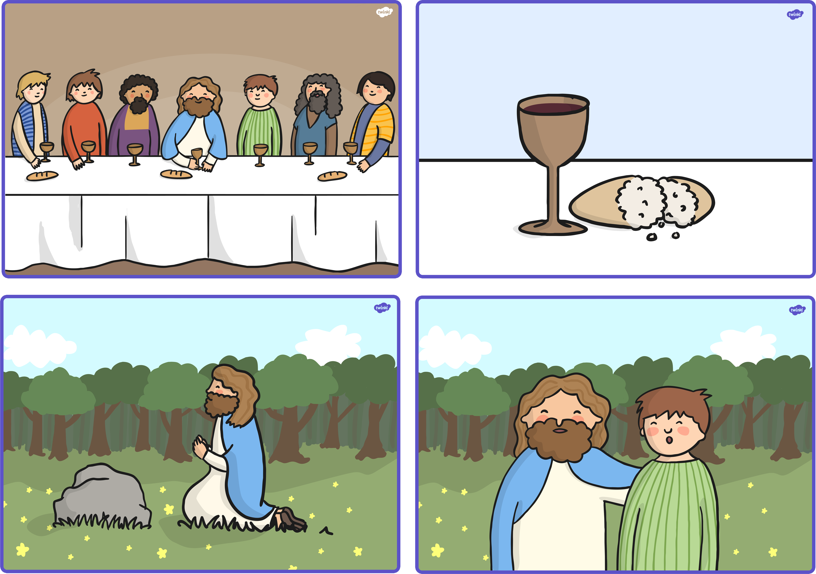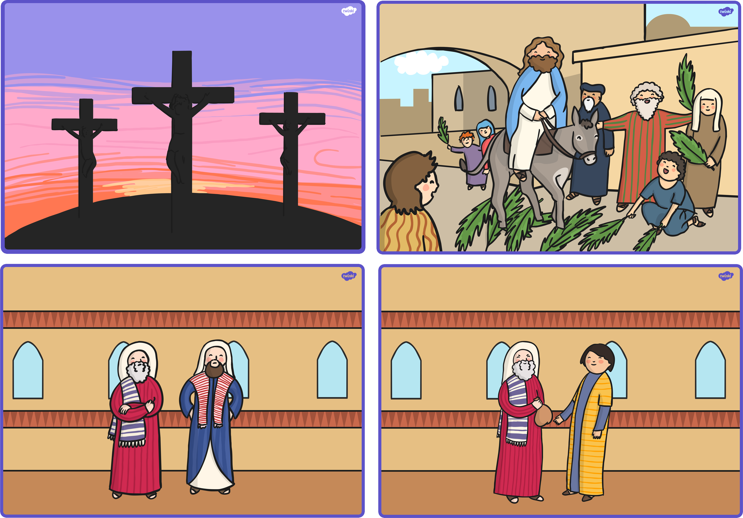

________________________________________________________________________________________________________________________________________________________________________

____________________________________________________________________________________________________________________________________________________________________________

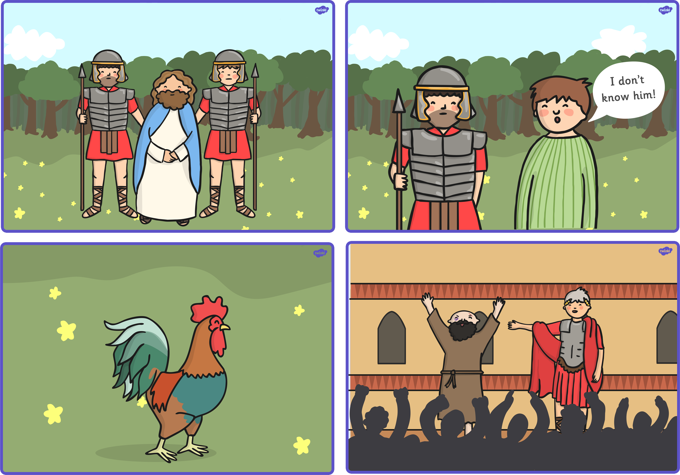

____________________________________________________________________________________________________

________________________________________________________________________________________

**R A G**