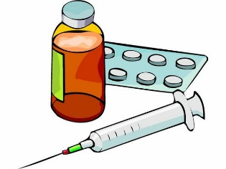
Can I say why people use medicine?
Where can you get medicine from?
Can you draw and label some people and places?

Why do people take medicine?
________________________________________________________________________________________________________________

Circle who can give you medicine

friend teacher nurse mum stranger

doctor lollipop lady dad shopkeeper fireman

R A G

