Mrs Halim – (Level 2 – AT2)
LO: How do Jewish children celebrate Chanukah?
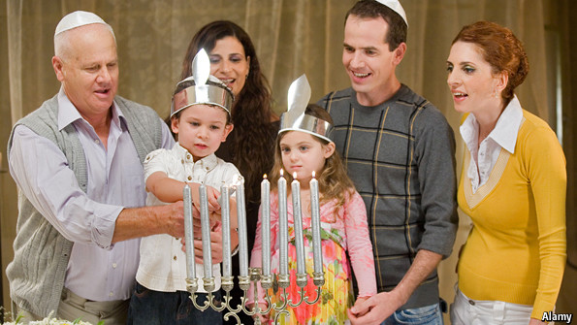
What do Jewish children do on Chanukah?
________________________________ | _______________________________

How does celebrating Chanukah make Jewish children closer to God?
__________________________________________________________________

Reflection: What do you celebrate that makes you feel special?
__________________________________________________________
R A G

