Mrs Halim
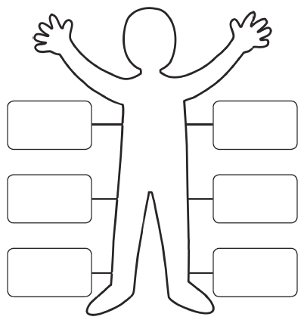
What do I want in a friend?
Reflection: Why are friends important?
________________________________________________________________________
________________________________________________________________________

