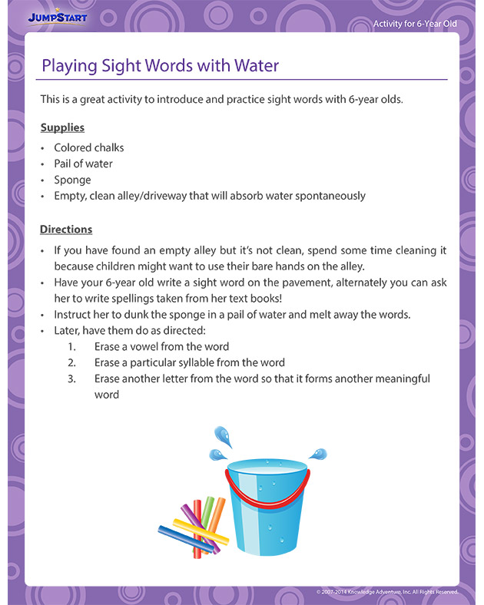
Alternatively this could be done on paper. Where the children write the word and then rip the piece of paper up or cross it out.
Erase a digraph from the word

