Mrs Halim
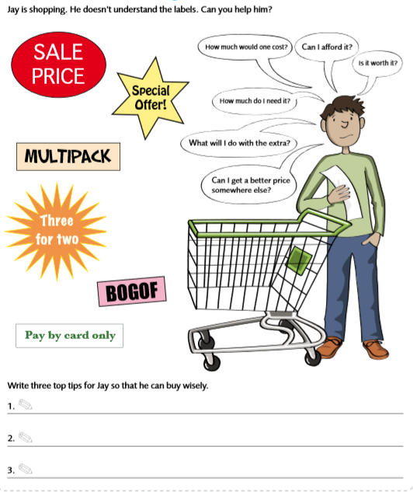
Can I understand the value for money?

