Indoor maths game Thursday: Bingo
Bingo is a perennially fun game that can be enjoyed by people of all ages, and this version puts a mathematical twist on this classic game, as a way to boost multiplication skills.
What you need to play:
- Paper to write numbers down on
How to play:
Step 1: In this mathematical version of the game, all players write down 5 numbers, 0-20.
Step 2: A third person can lead the game and call out questions.E.g. 12+3.If your child has got 15 they can cross it off their list.
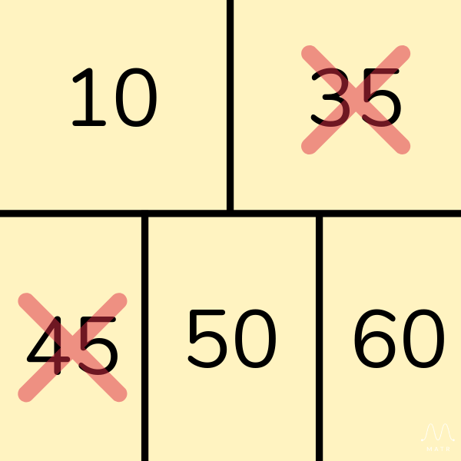
Step 3: If the player has an answer to the question on their bingo board, they can cross it out. First person to cross out all their numbers is the winner.

