Tasty toast
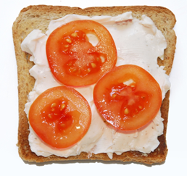
Ingredients
4 slices of bread
Complexity: low
100g soft cheese, reduced fat
Fruit or vegetables to add to the top, prepared (sliced/chopped)

Equipment
Toaster, plastic tongs, chopping board, table knife, 4 plates.

Method
- Place the bread in the toaster and set it to toast.
- When the bread is toasted, wait for a few moments to allow it to cool slightly and
remove using the tongs.
- Place the toast on the chopping board.
- Spread the soft cheese onto the toast.
- Arrange the fruit or vegetables on top.
- Cut each slice into quarters and serve on the plates.

Top tips
- Try toasting different types of bread such as bagels and crumpets.
- When working with four children, increase the amount of equipment so they can work in pairs or separately to do their own spreading and fruit or vegetable arranging.

Topping ideas

Spreadable toppings | Fruit or vegetables
- soft cheese, reduced fat  - cottage cheese, reduced fat  - mashed avocado | - sliced banana, strawberries, apple or dried apricots  - sliced tomatoes or cucumber  - chopped pineapple or grapes  - a sprinkle of sultanas or dried cranberries

Food skills
- Weigh.
- Spread.
- Cut.
- Divide.

