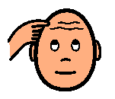



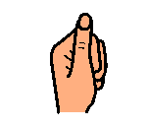





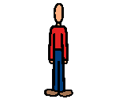





and

and



Sung to ‘Old MacDonald has a Farm’

What’s the sound that starts these words

**th** is the sound that starts these words

With a **th** here and a **th** there,

Here a **th** there a **th** everywhere a

**th th**

**th**  is the sound that starts these words

and