**Can you write a sentence for each picture of the Easter Story? Draw a picture of how Christians believe Jesus died.**

**Can I recall parts of the Easter story?**

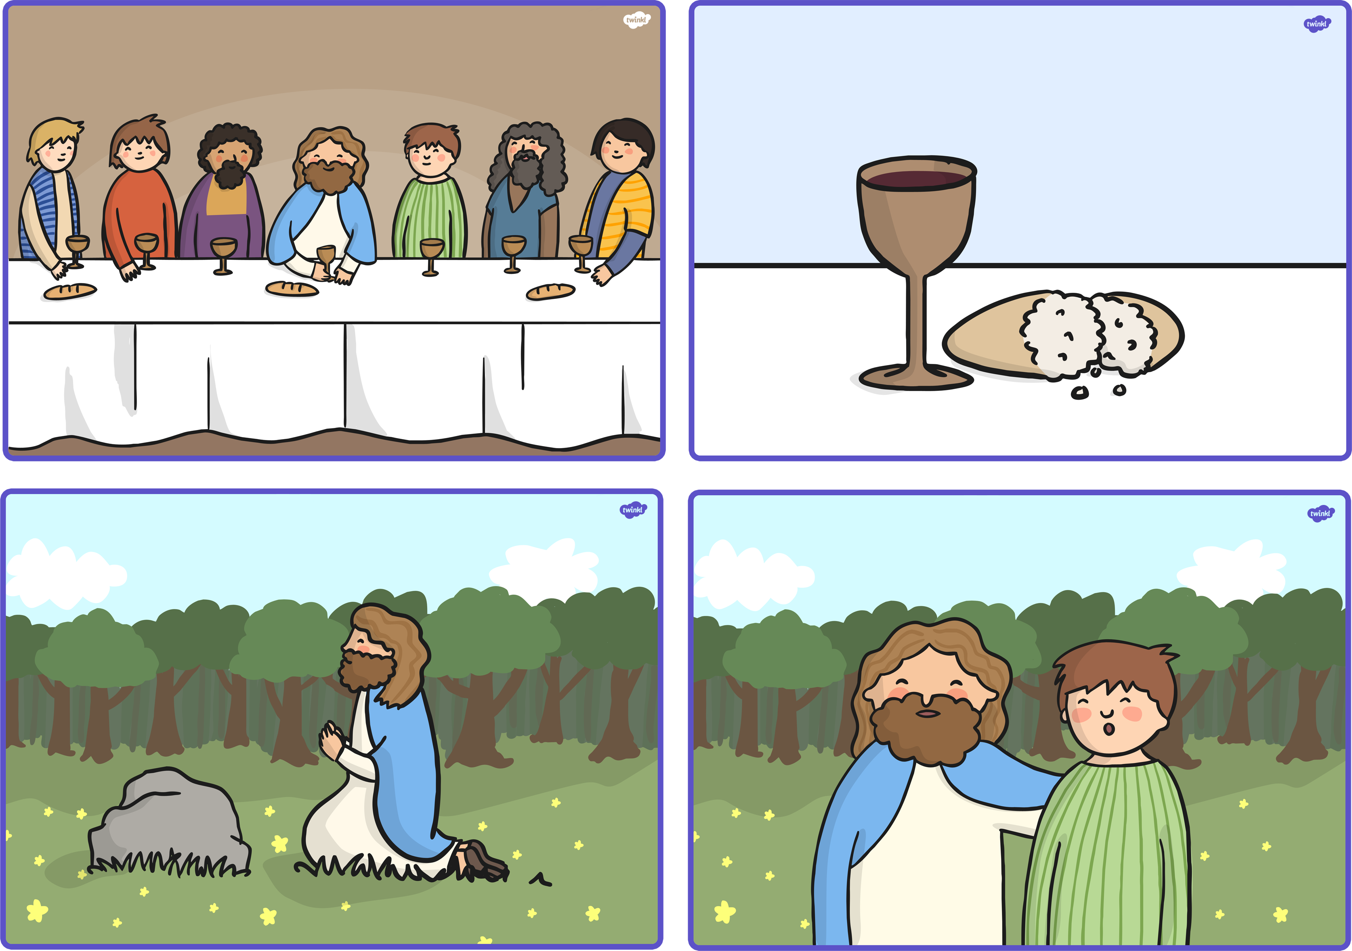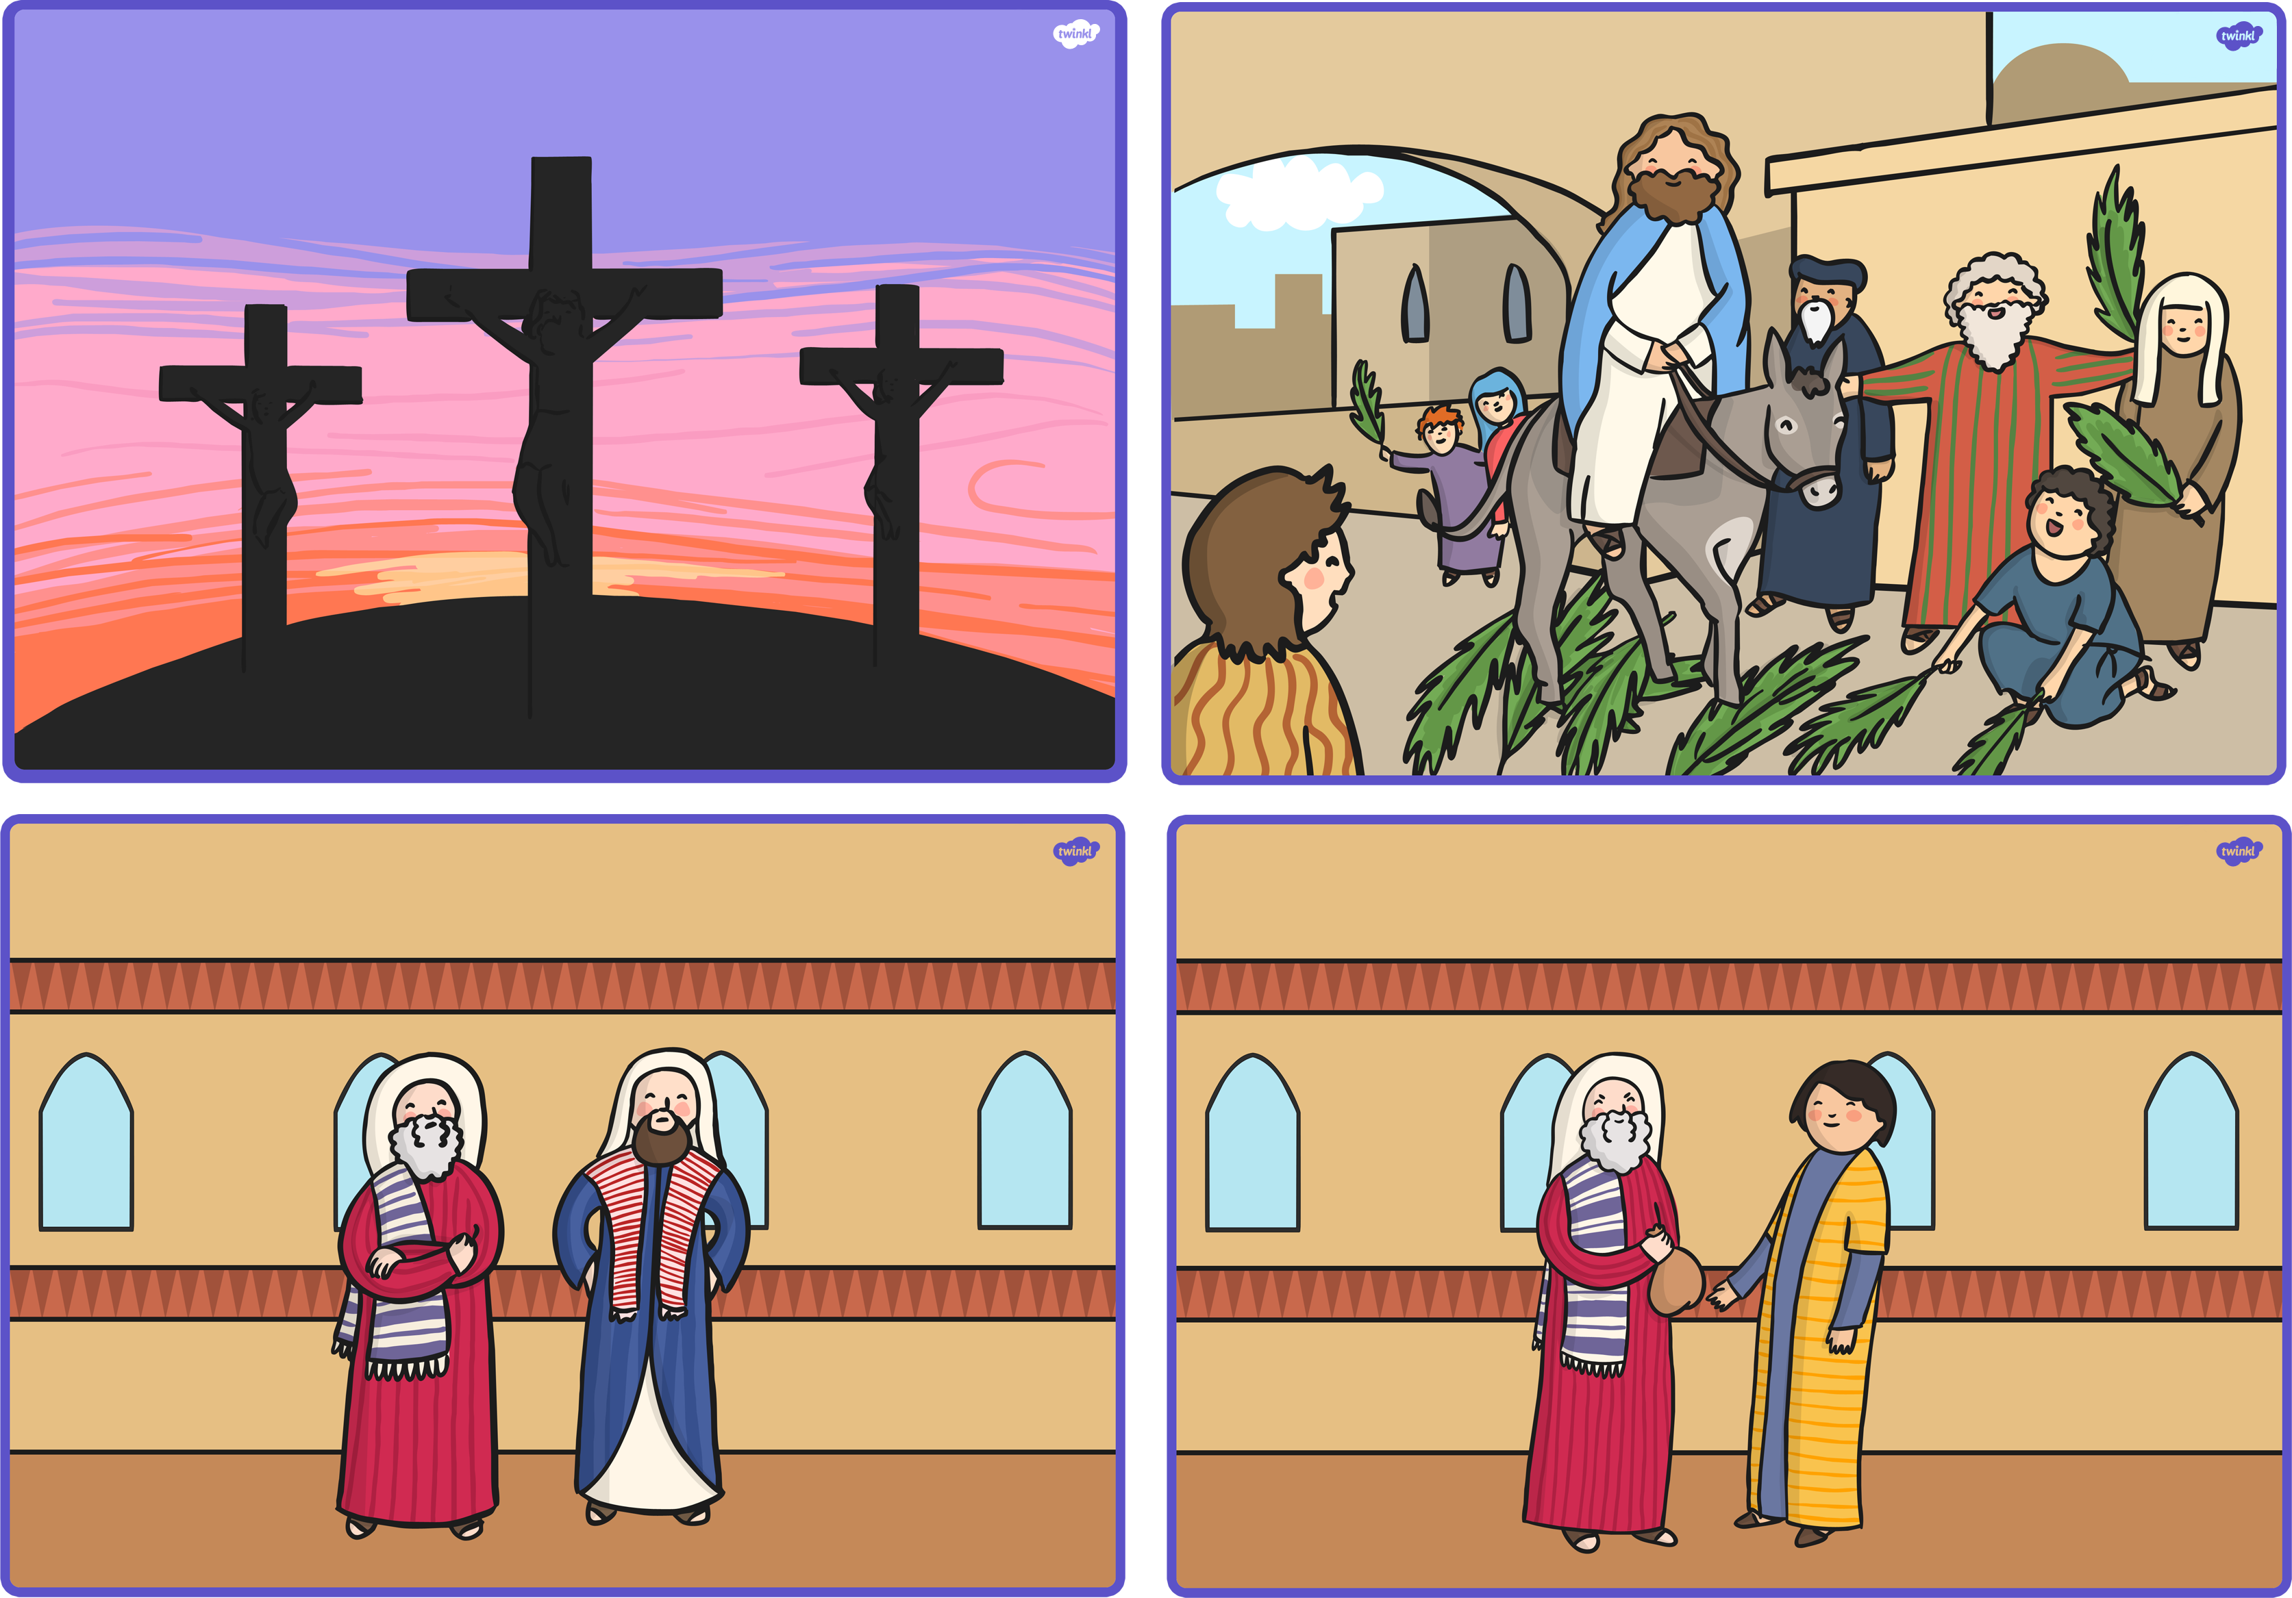

________________________________________________________________________________________________________________________________________________________________________

____________________________________________________________________________________________________________________________________________________________________________

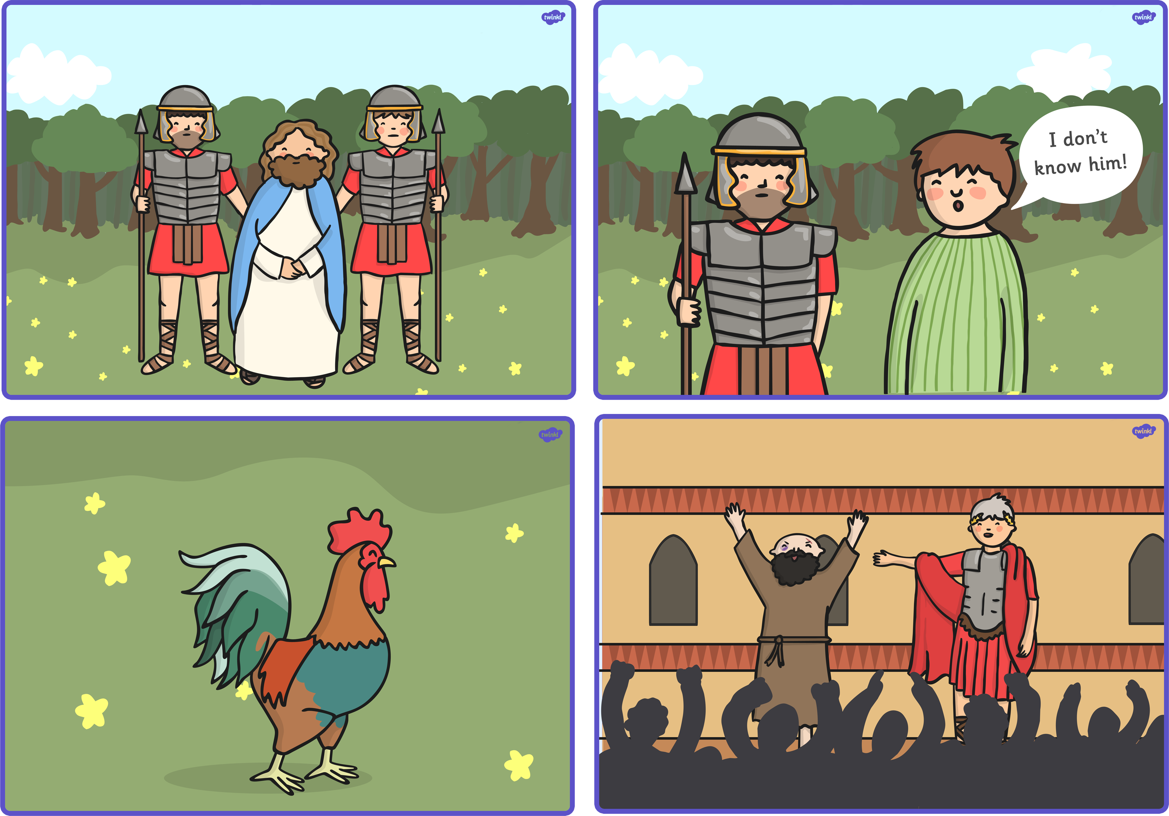

Jesus was put on a cross to die. Christians believe that Jesus came to life again.

Jesus went to the garden to pray. Some soldiers arrested him.

**R A G**