Read Write Inc Fred Games
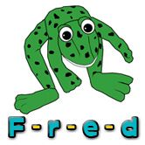
Meet the famous Fred.
Fred helps the children to read words (blending) and write words (segmenting).
Fred in your Head
The children are currently learning to read words in their head. They are asked to say the letters silently in their head and read the word aloud.
Please write the following words (in green) onto paper or card…
dig top gap kit up
mud cup back kick lock
Extend- The children need to be able to read the words at speed.
Encourage your children to read the word by sight.
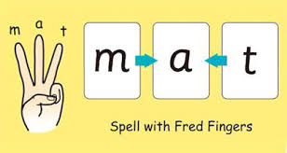

Fred Fingers
The children are currently learning to spell words using their fingers.
Ask your child to get their ‘Fred Fingers’ ready. Choose one of the words above (don’t let the children see the word) and say “Dig!”
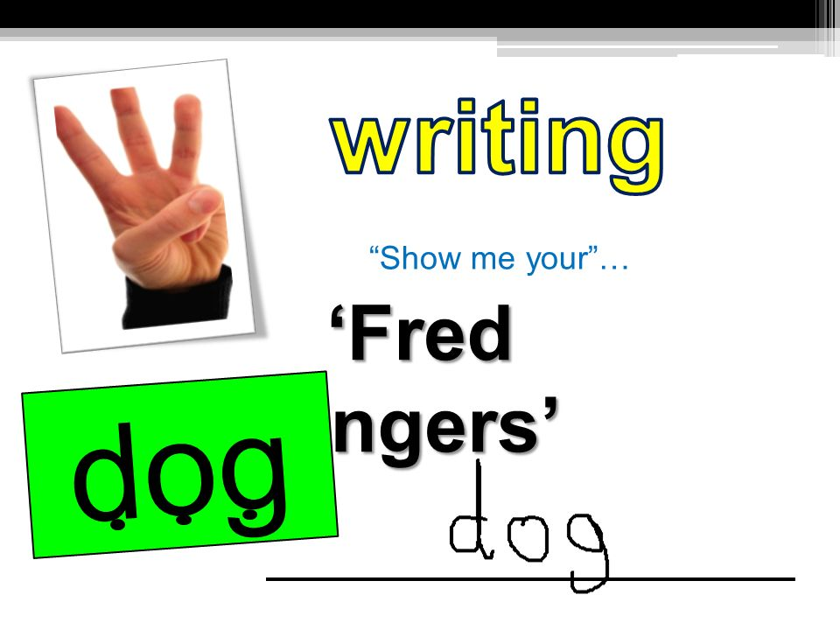
The children will use their fingers to spell the word.
Extend this by asking your child to ‘say and write’ the word.

