Activity Menu: Year 2
Here are some activities for you to choose from and complete. They are about things that we have learned before. You can use the internet or books to help you.
RE – Christianity – Easter Sunday | PSHE – Medicines - Safety
Easter Story
https://www.bbc.co.uk/teach/class-clips-video/religious-studies-ks1-the-christian-story-of-easter/zhgv47h
Attached:  Postcard about events of Easter Sunday  P4C – Is Easter a happy or sad time? | Attached:  Medicine Safety Poster  Vocabulary bullseye

Mrs Halim and Mrs Oseman

Date: _______________________________________________________
Can I say how I can keep myself safe around medicines?

Design a poster telling people how to be safe around medicines.

Name: ______________________________________________________
Is Easter a happy or sad time for Christians?

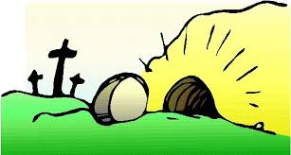

________________________________________________________________
________________________________________________________________
________________________________________________________________
________________________________________________________________
________________________________________________________________
________________________________________________________________
________________________________________________________________
Name____________________________________
Can I write a postcard about what happened on Easter Sunday?

