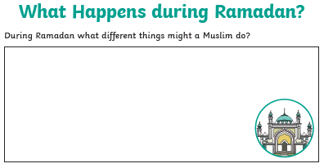
Tuesday 21st April 2020 – Mrs Halim
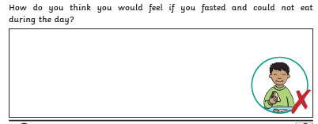

Reflection: What special deeds can you do during Ramadan?

_________________________________________________________________________

