Menu for an Omnivore
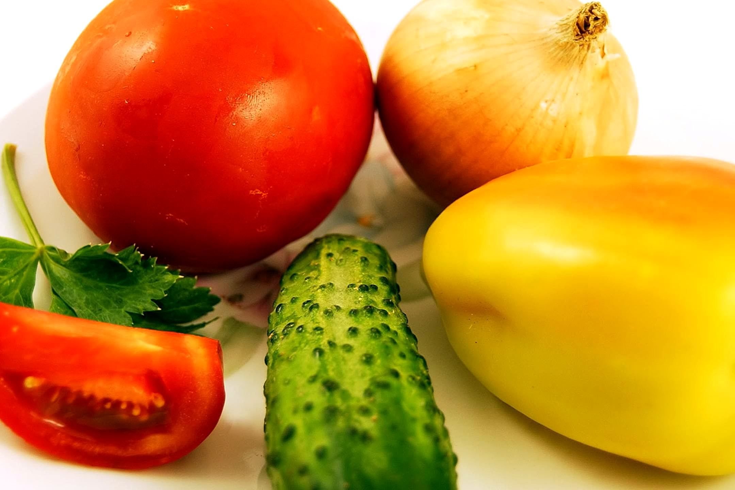
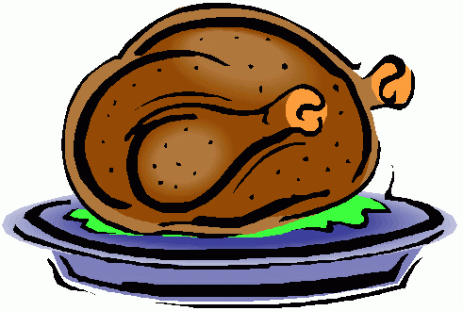
Type of animal: ___________ Name of pet: ____________

Breakfast | Lunch | Tea
Owner of pet: __________________

